# Register Azure Free Pass

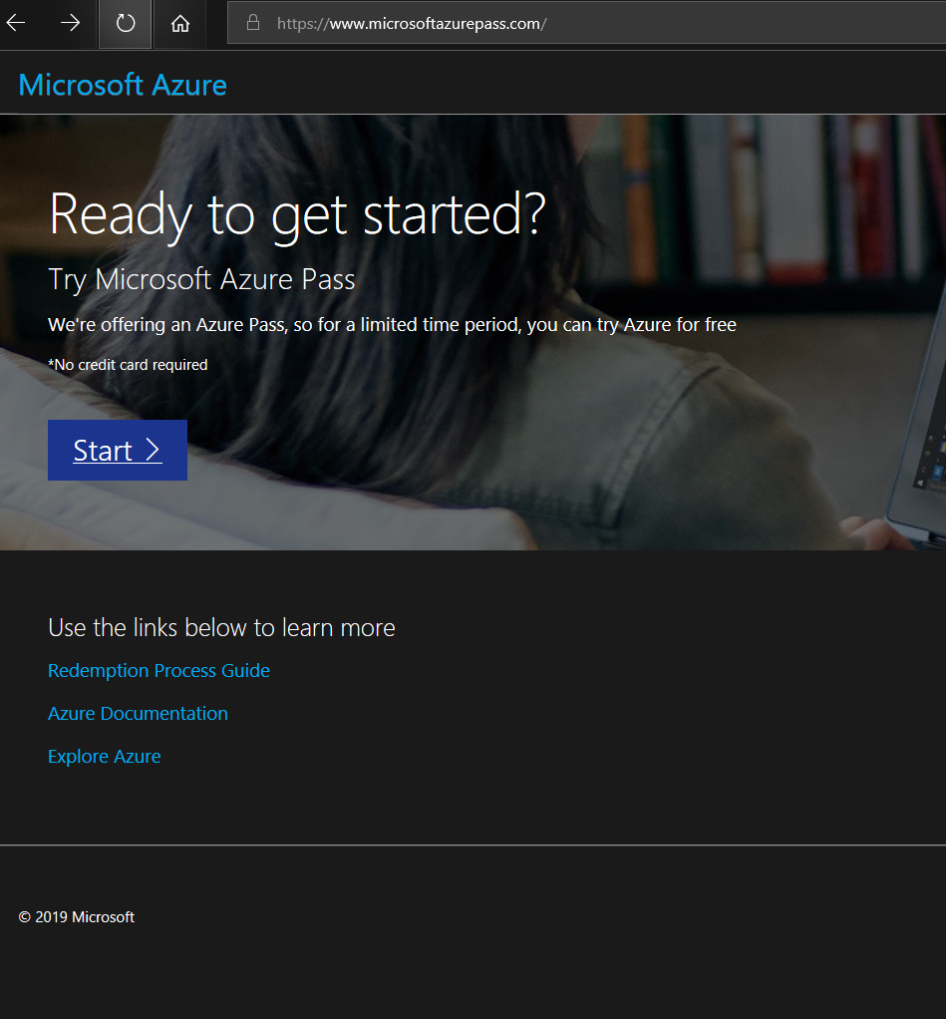

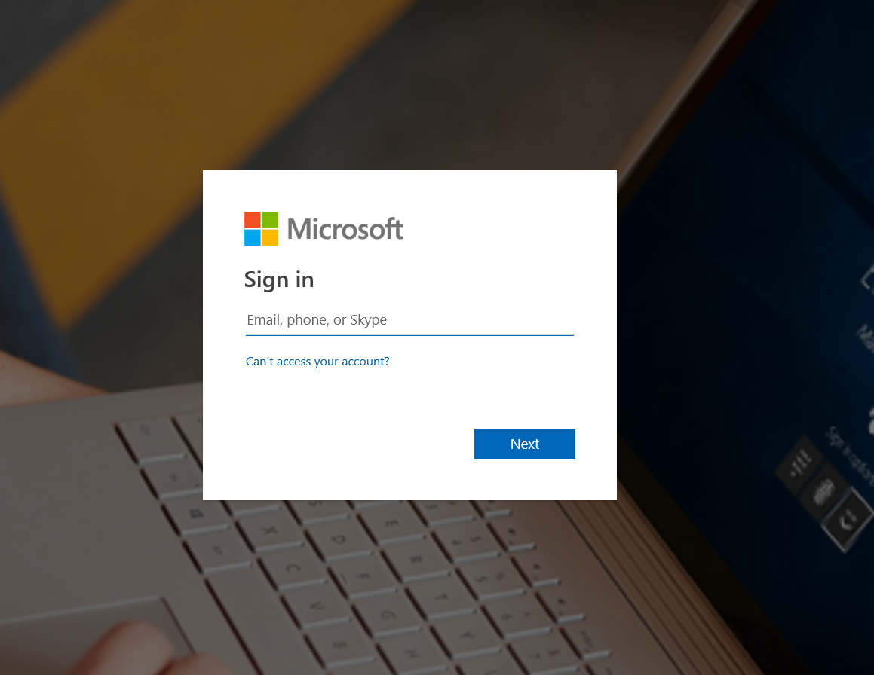

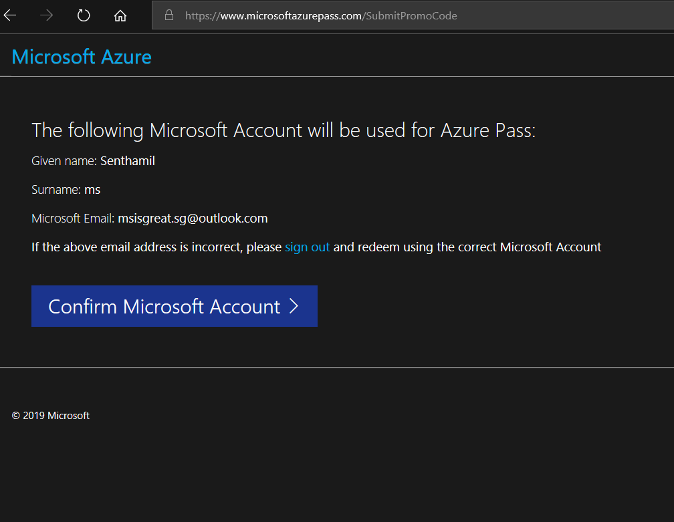

Enter Promo Code

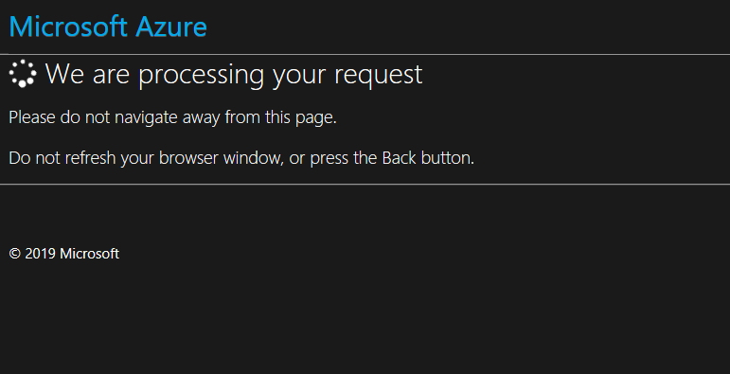

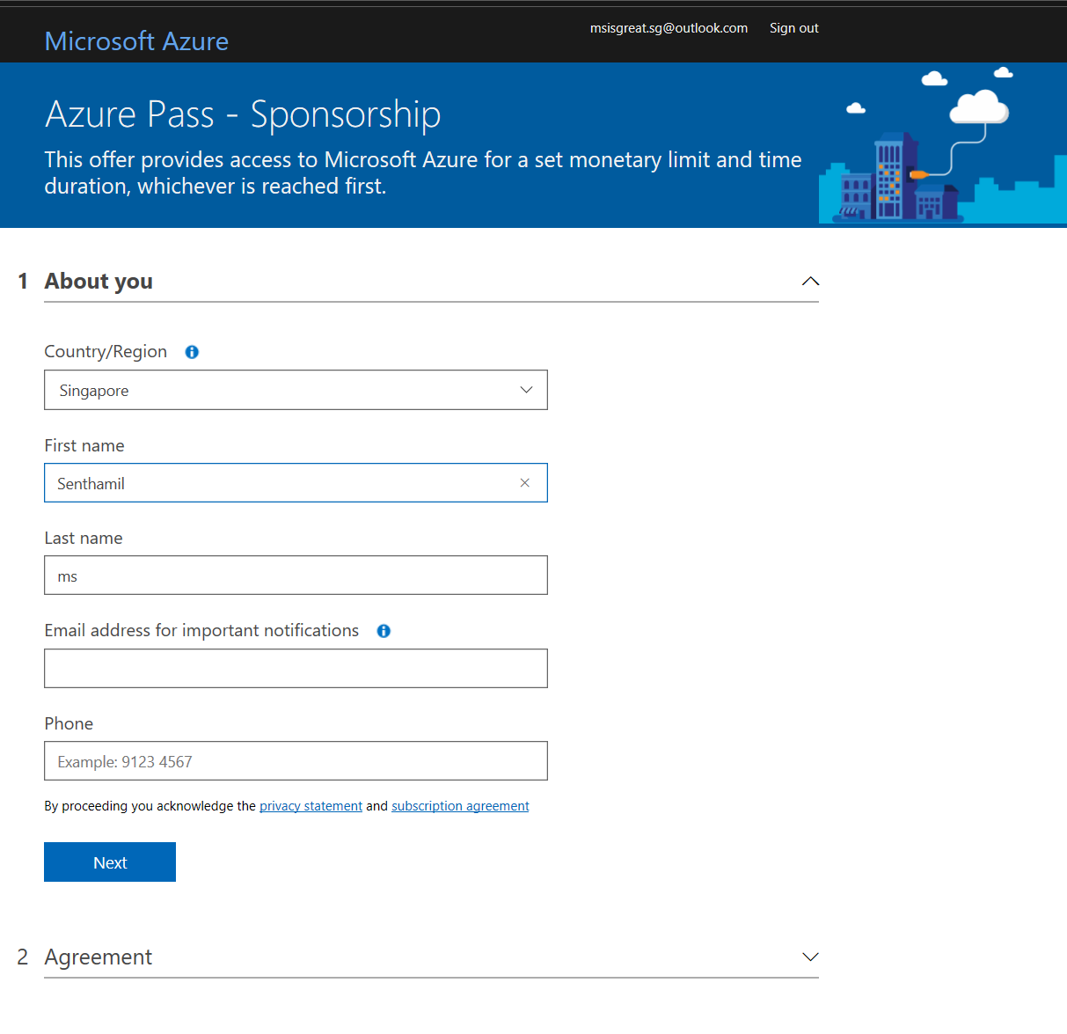

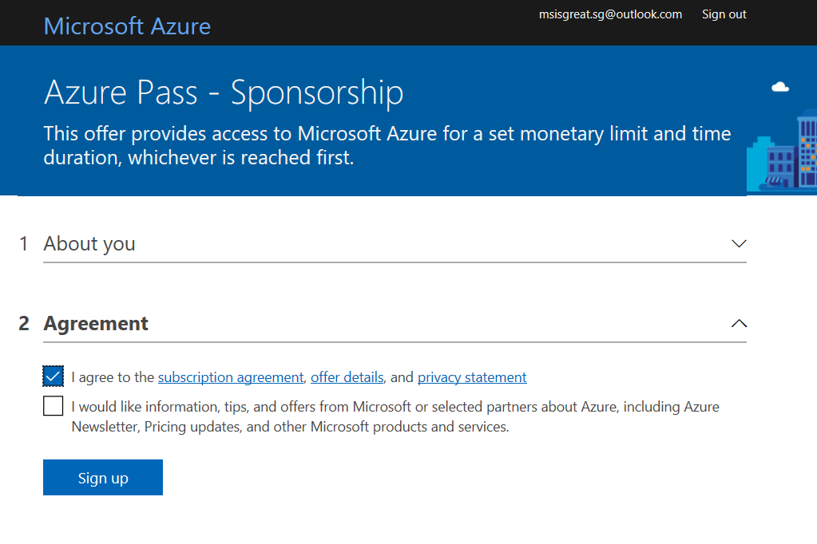

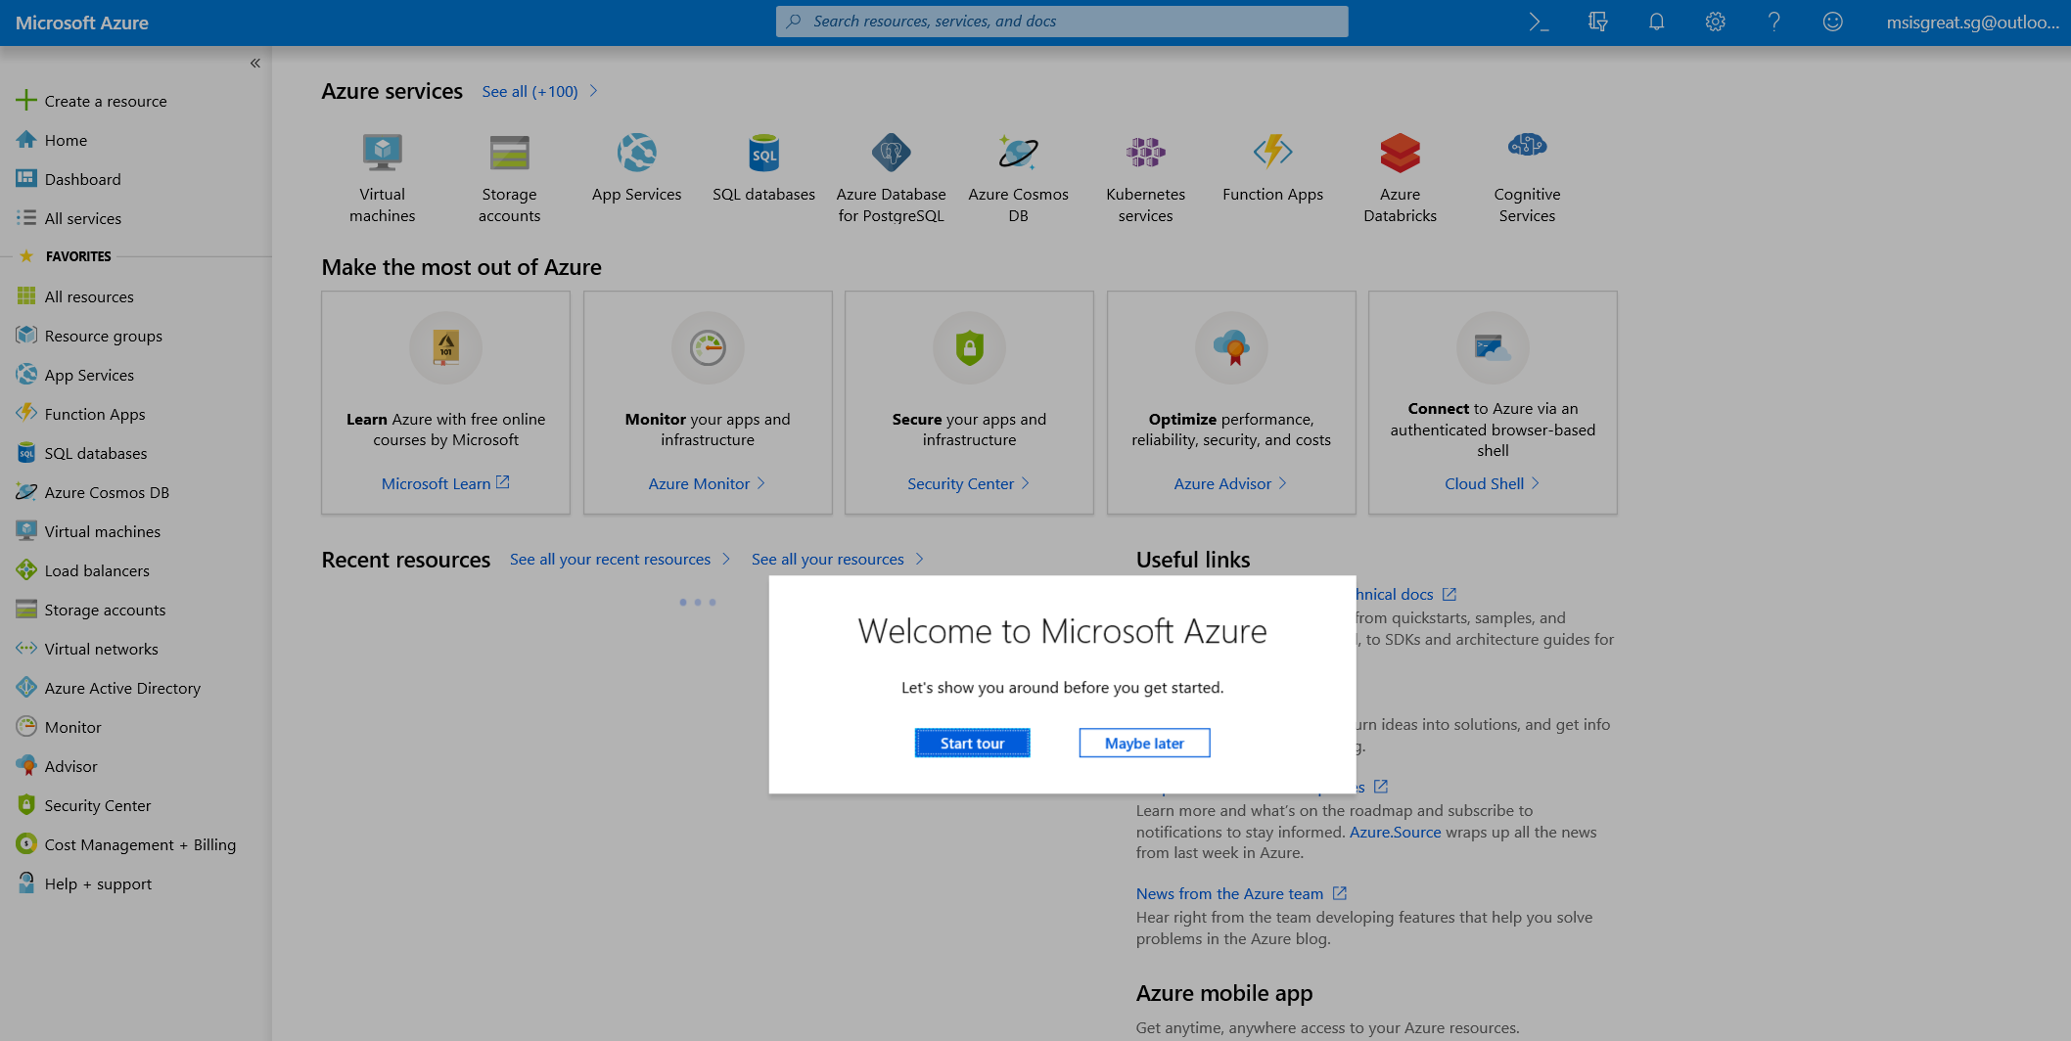

Successfully claimed the promo code

# Azure Blockchain Workbench

Login to Azure using the <https://portal.azure.com>

Navigate to the Resource Group

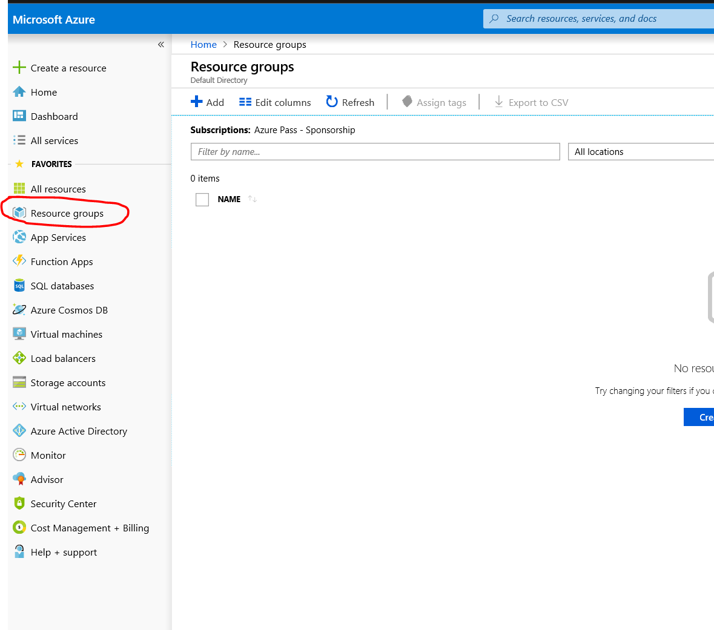

Create New Resource Group by Clicking on + Add icon to top.

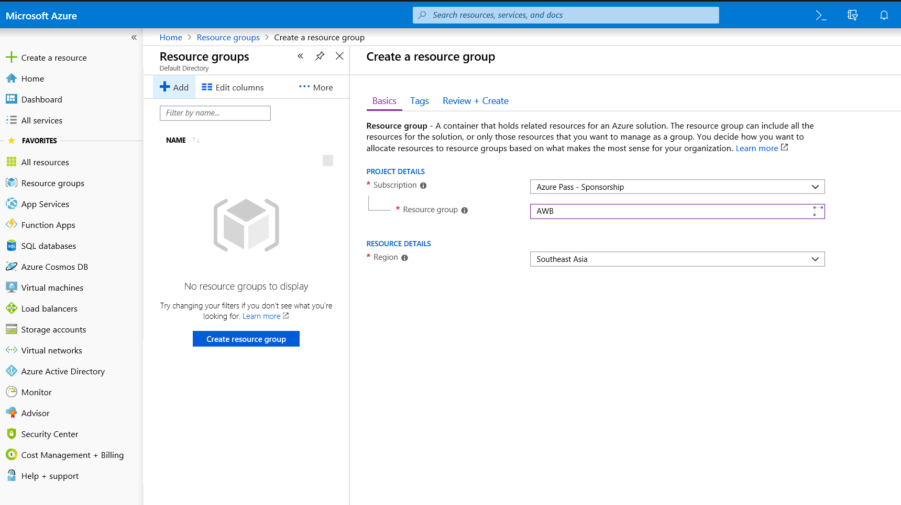

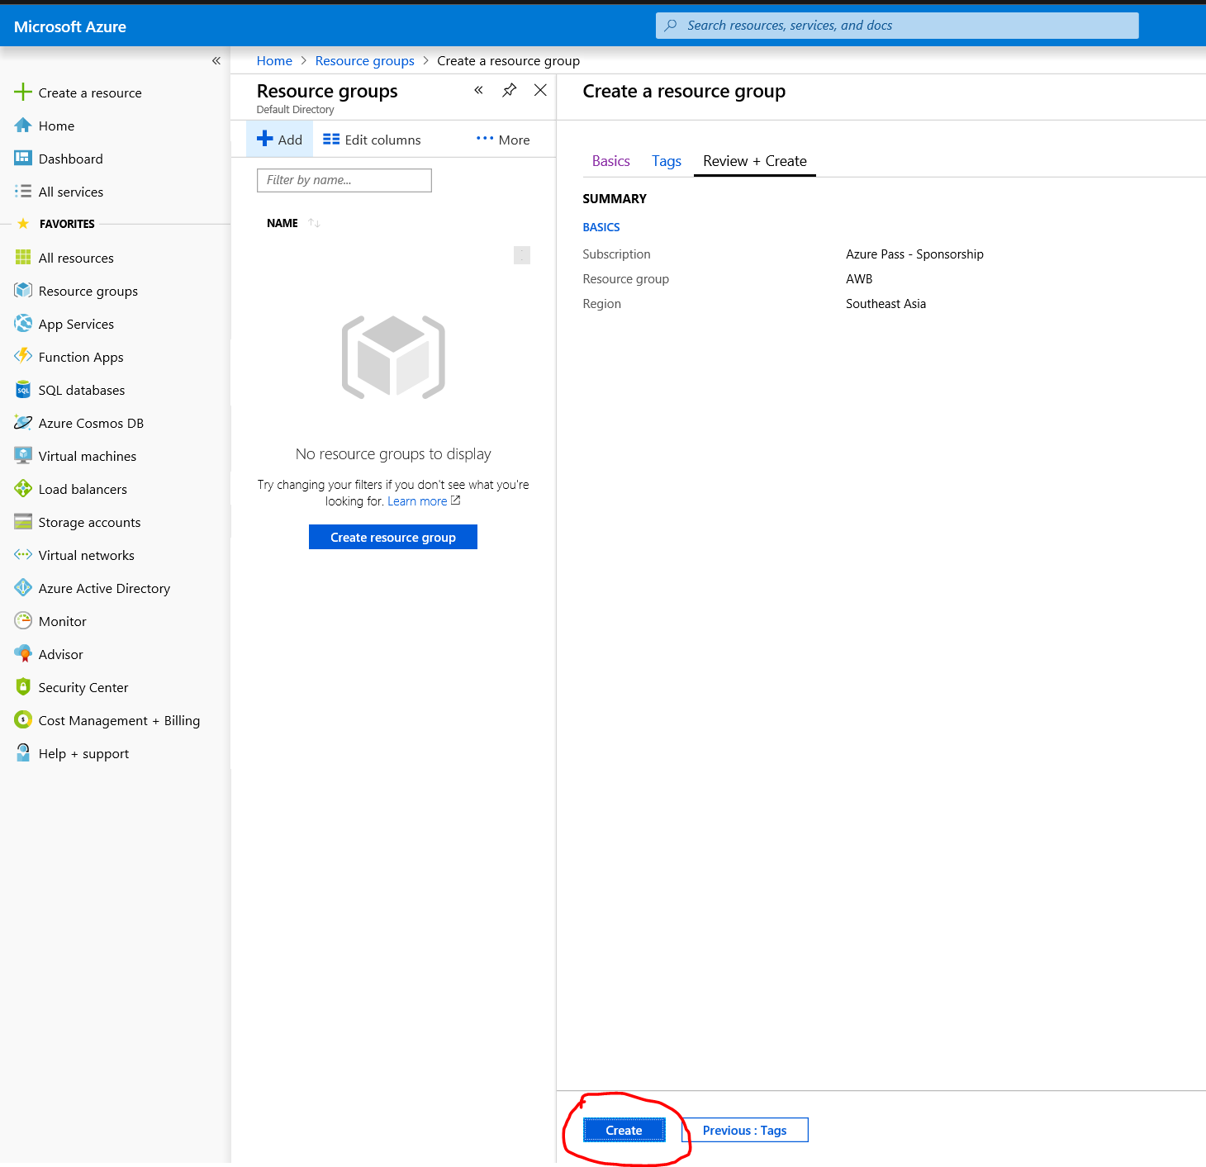

Successfully after creation you will see the AWB resource group. It is not mandatory to create resource group, this is just to organize all the resources we create to group into one group. Easy to maintain in future.

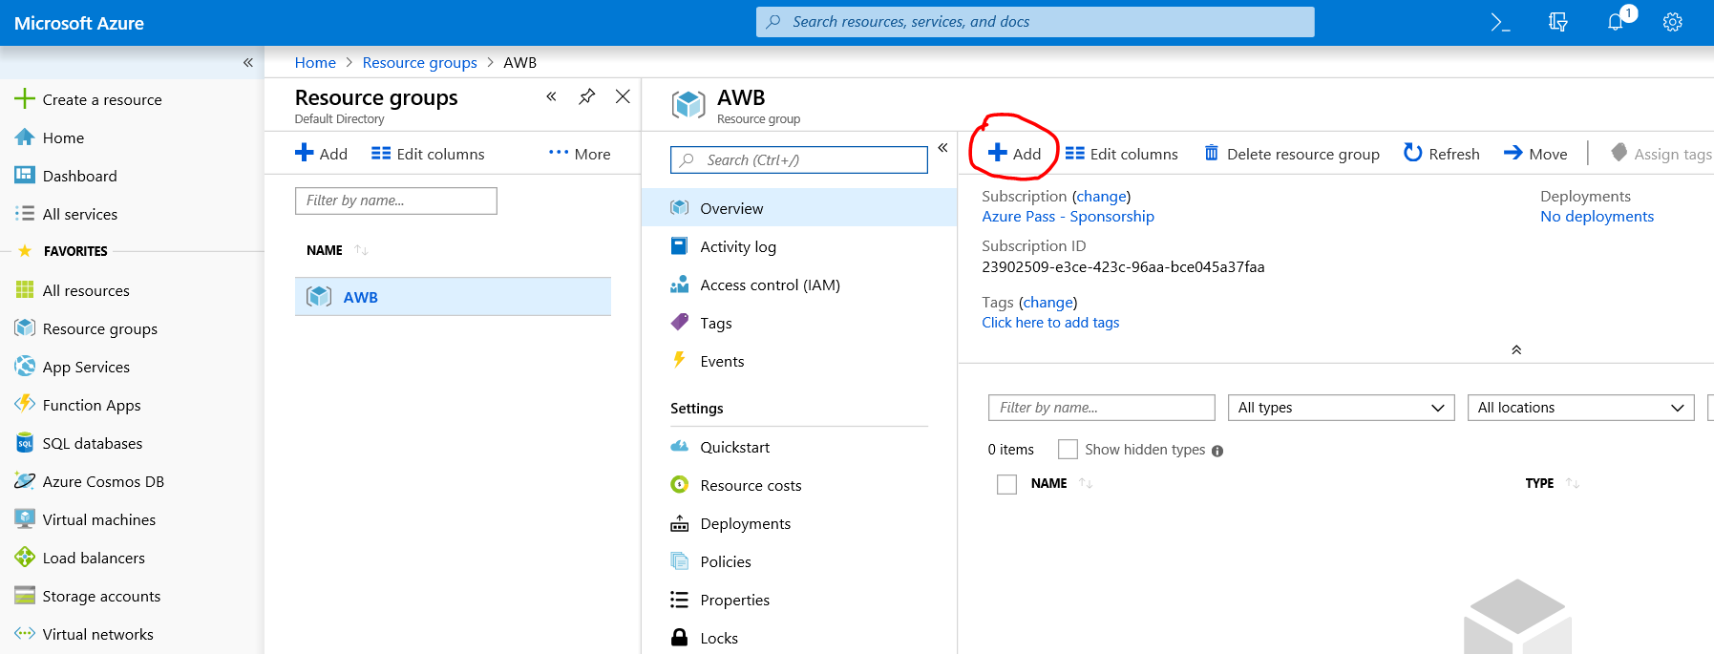

Once the Add button is clicked you will have search option. Type Blockchain in the search box and filter by blockchain. You will see Azure Blockchain Workbench. Click that option

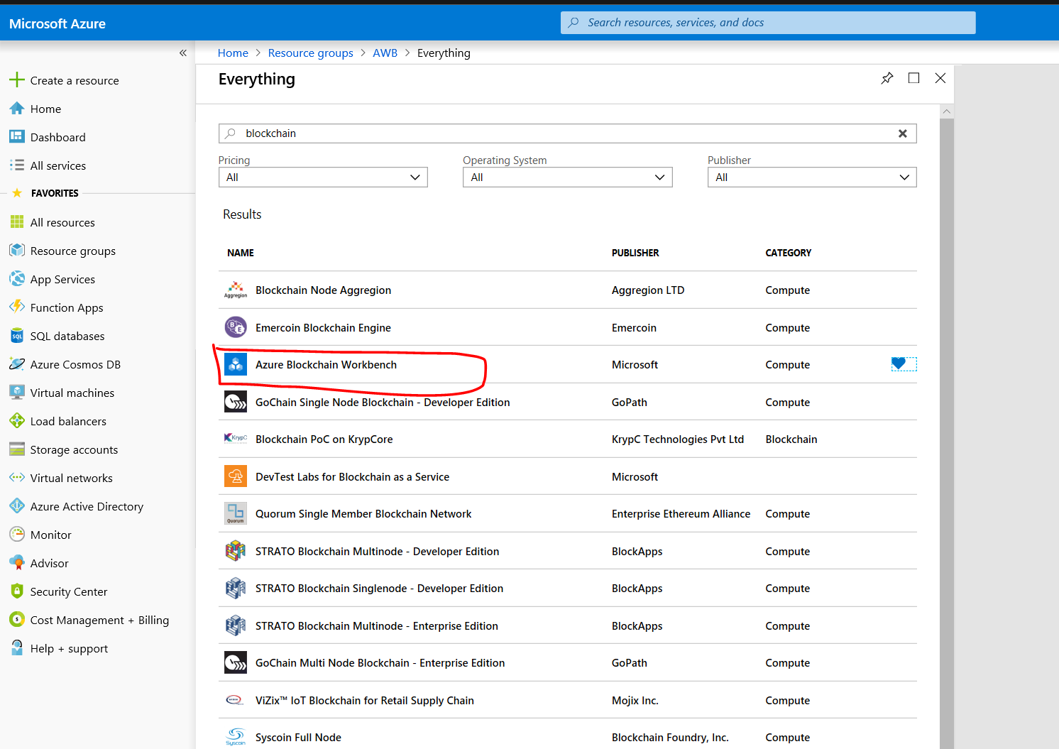

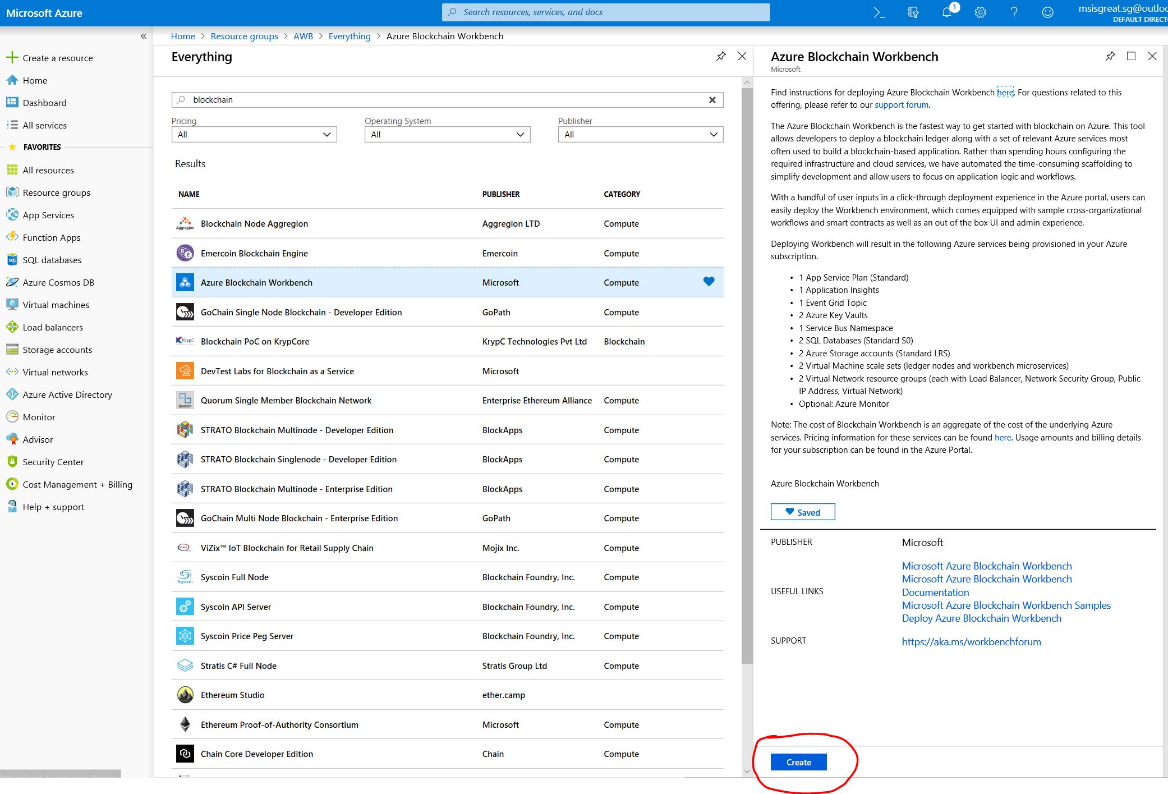

Enter the details needed on the next screen to create the Azure Blockchain Workbench

There are 4 steps in creation of the Azure Blockchain Work Bench

Step 1 Basics

Step 2 Advanced Settings

Step 3 Summary

Step 4 Buy

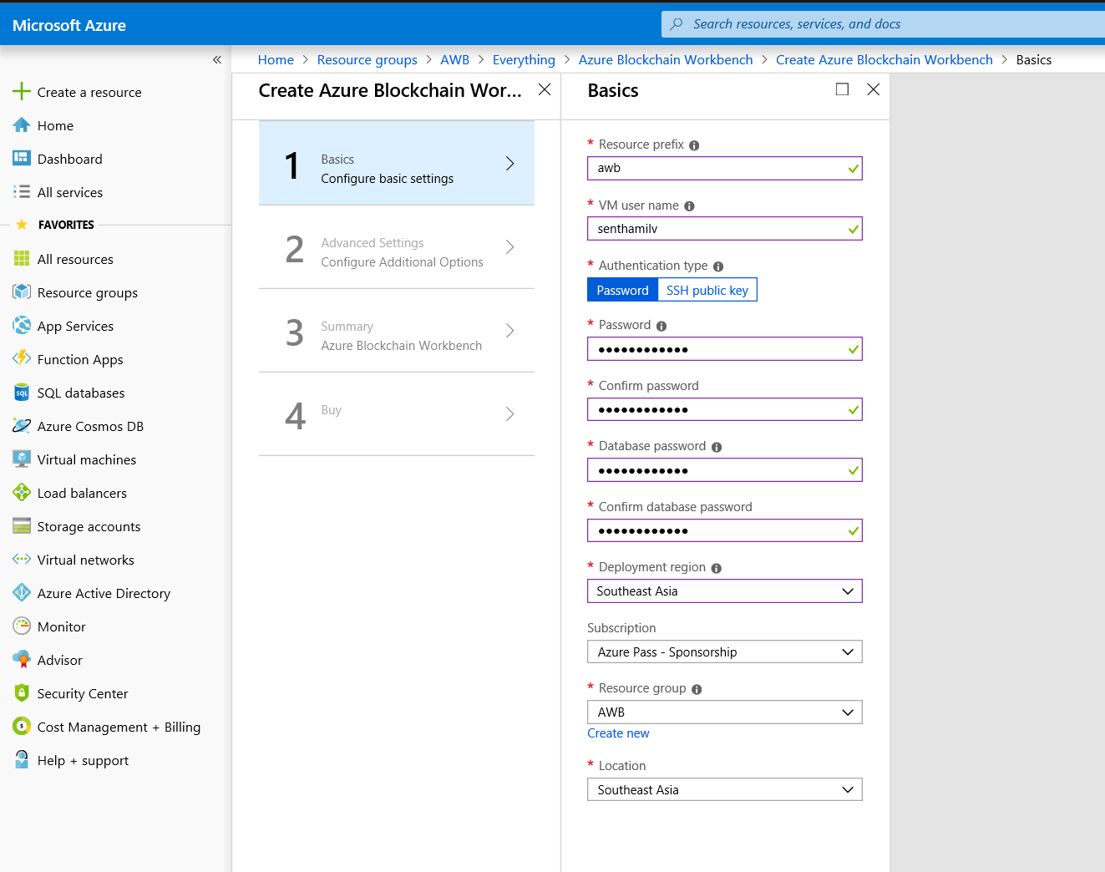

Click on Ok button at the bottom of page to accept these values

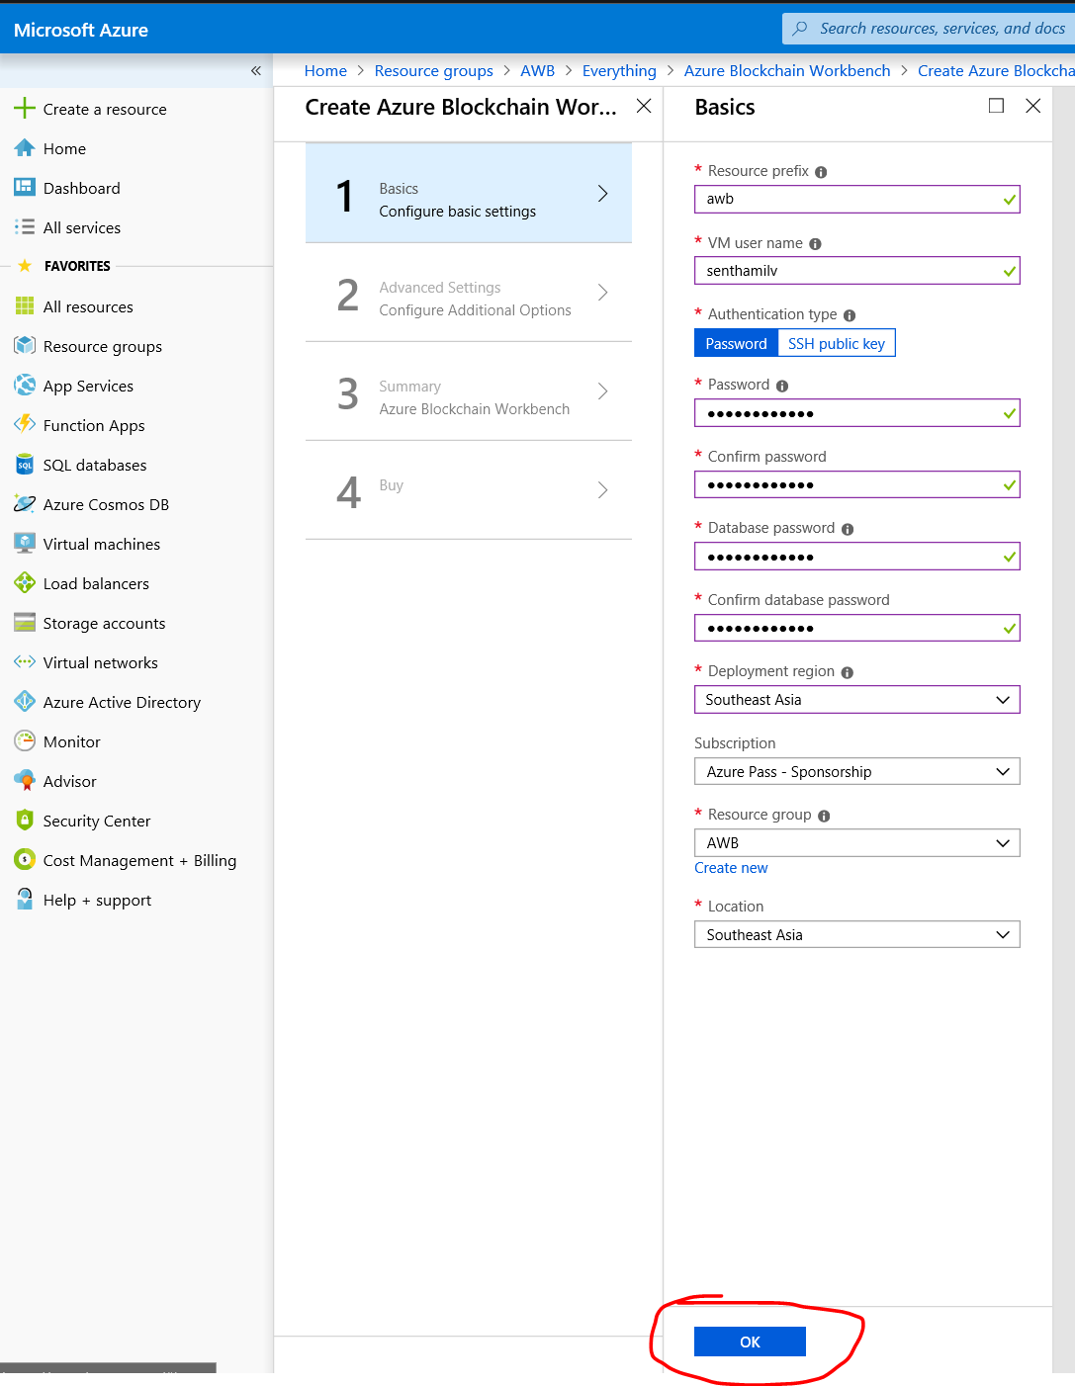

For the next screen accept the default settings and click Ok button

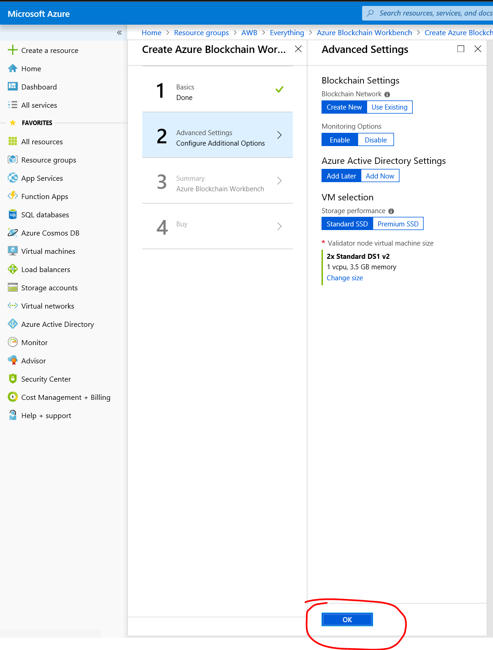

Once all details are entered the validation screen will popup. Wait till the validation is complete to get Ok button enabled in the screen.

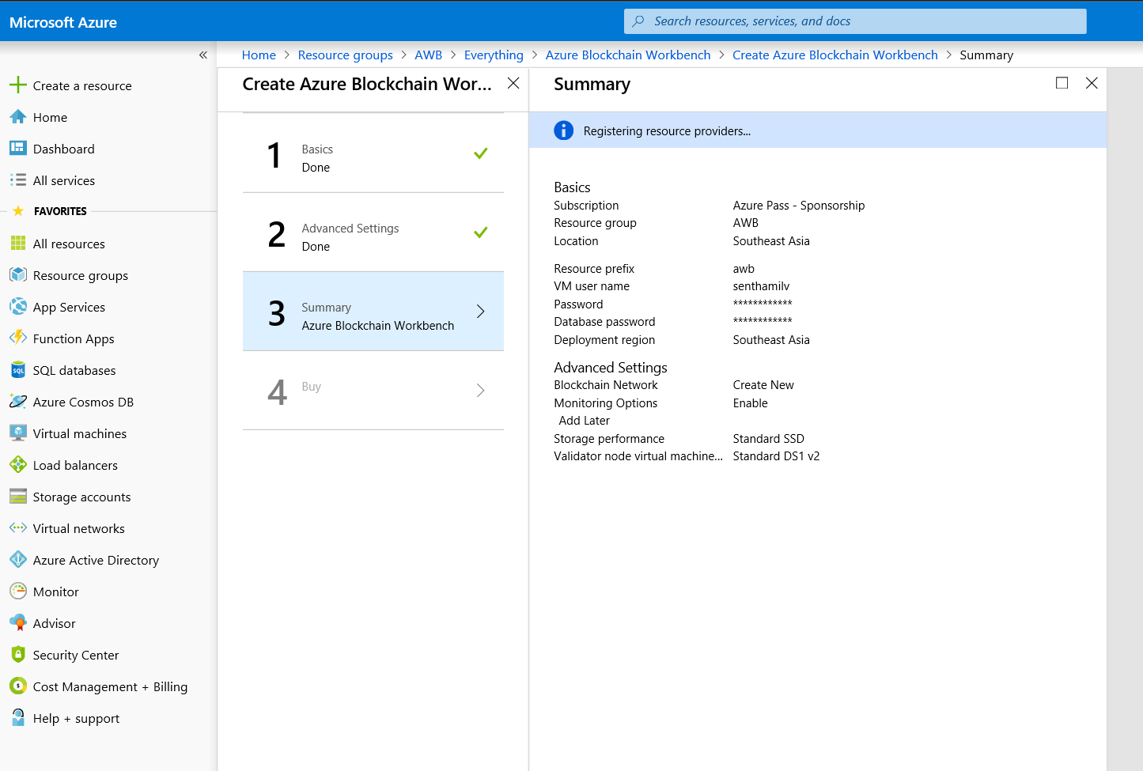

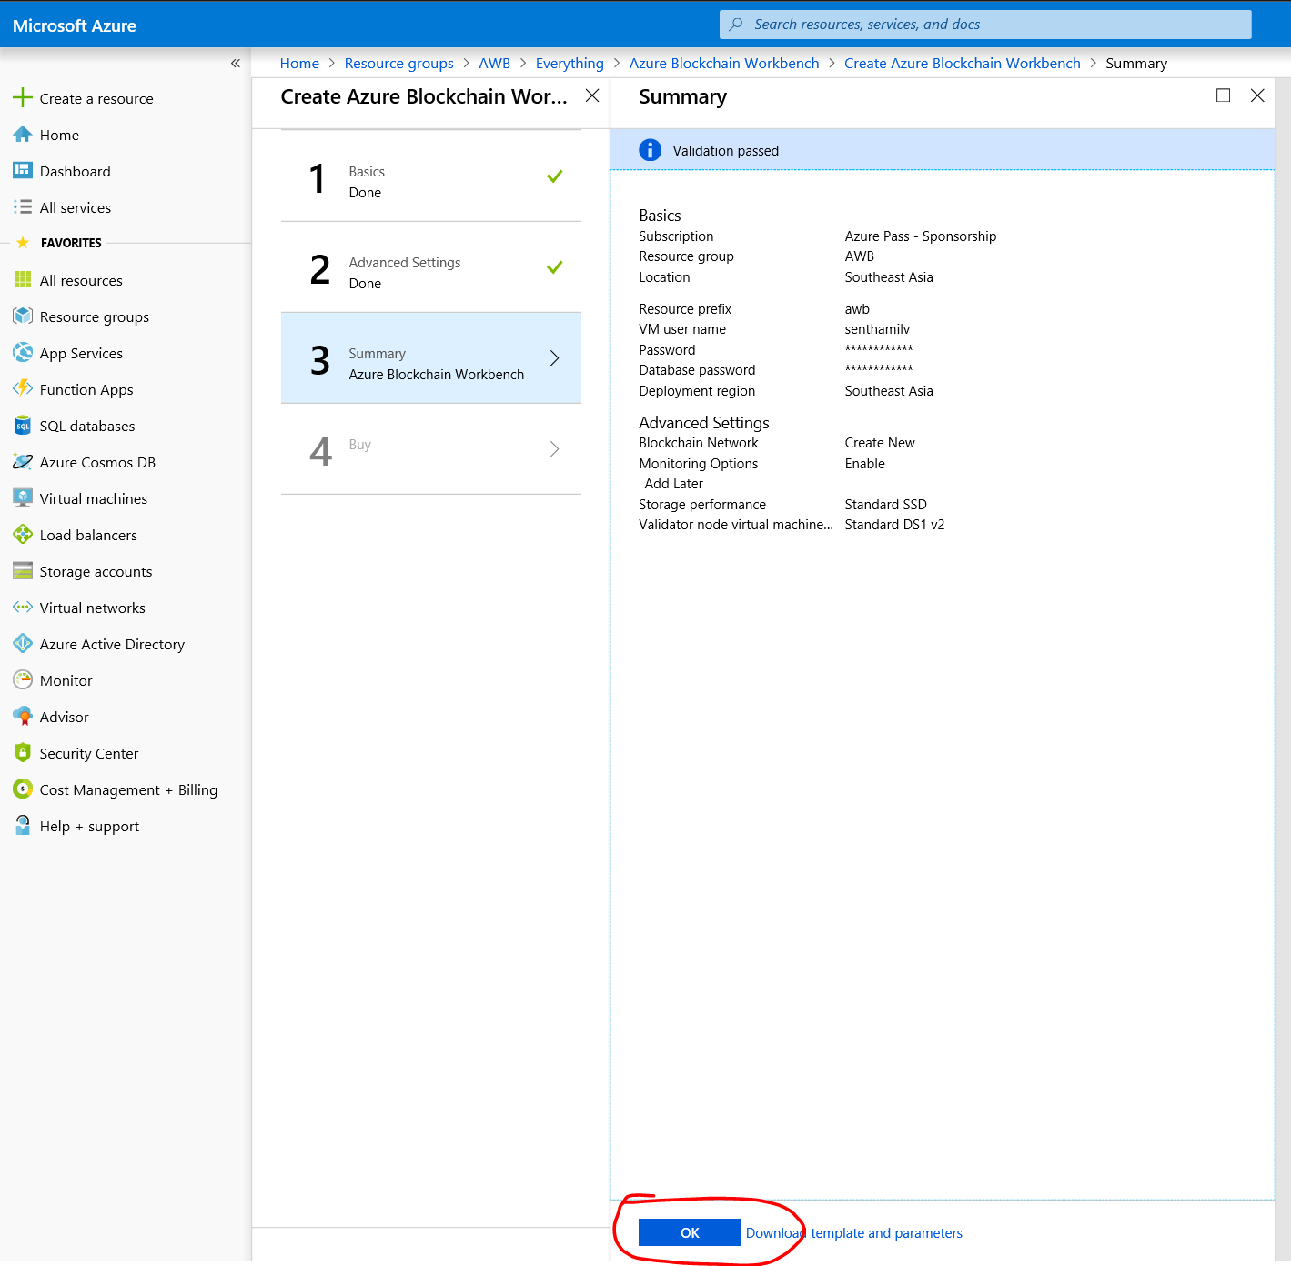

Step 4: Buy

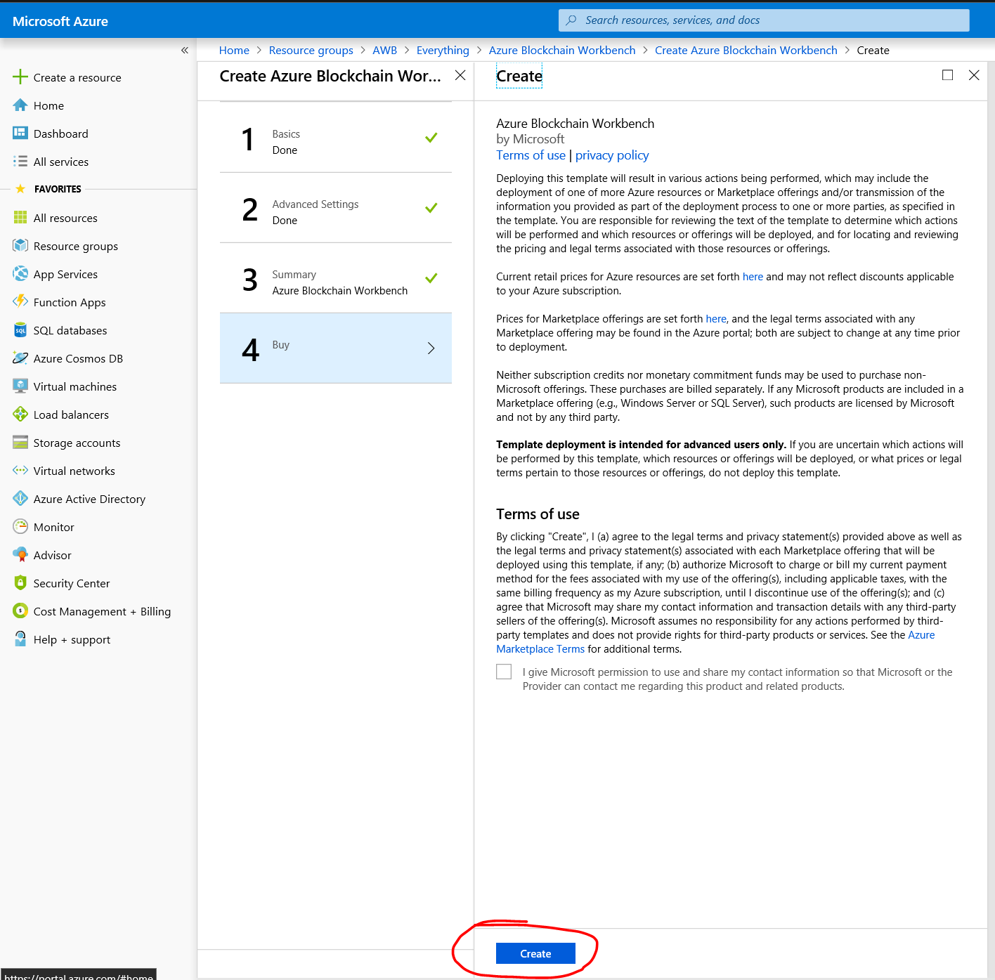

Once you click on Create it takes almost 15 to 30 minutes to create the Azure Blockchain Work Bench.

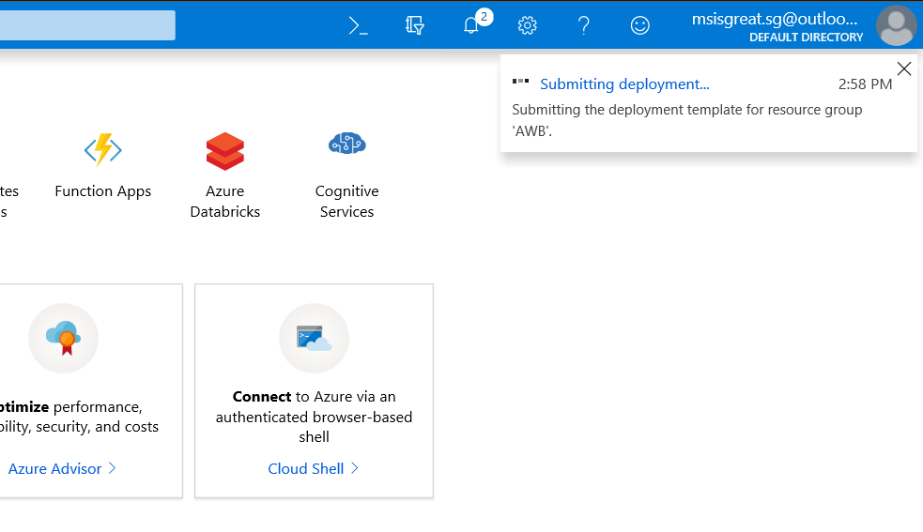

You can track the status by using the Top notification icon.

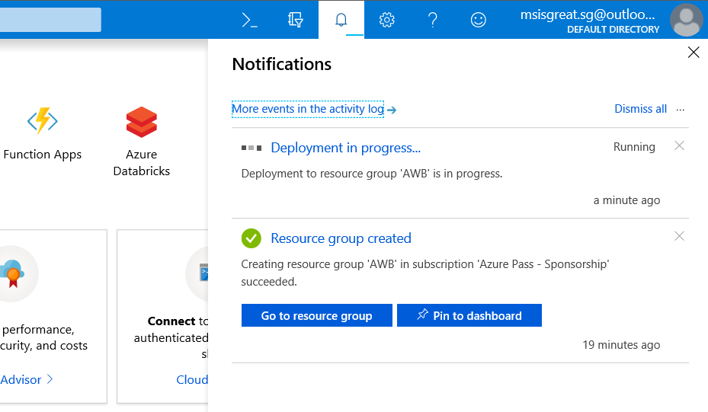

To check the deployment status use the below option any time

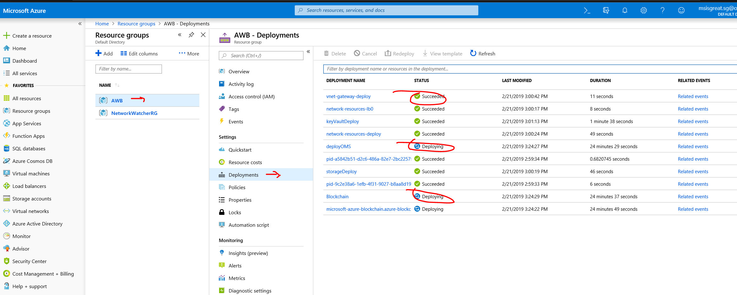

# Blockchain Application URL

Once successfully deployed Navigate to the Overview to check the URL

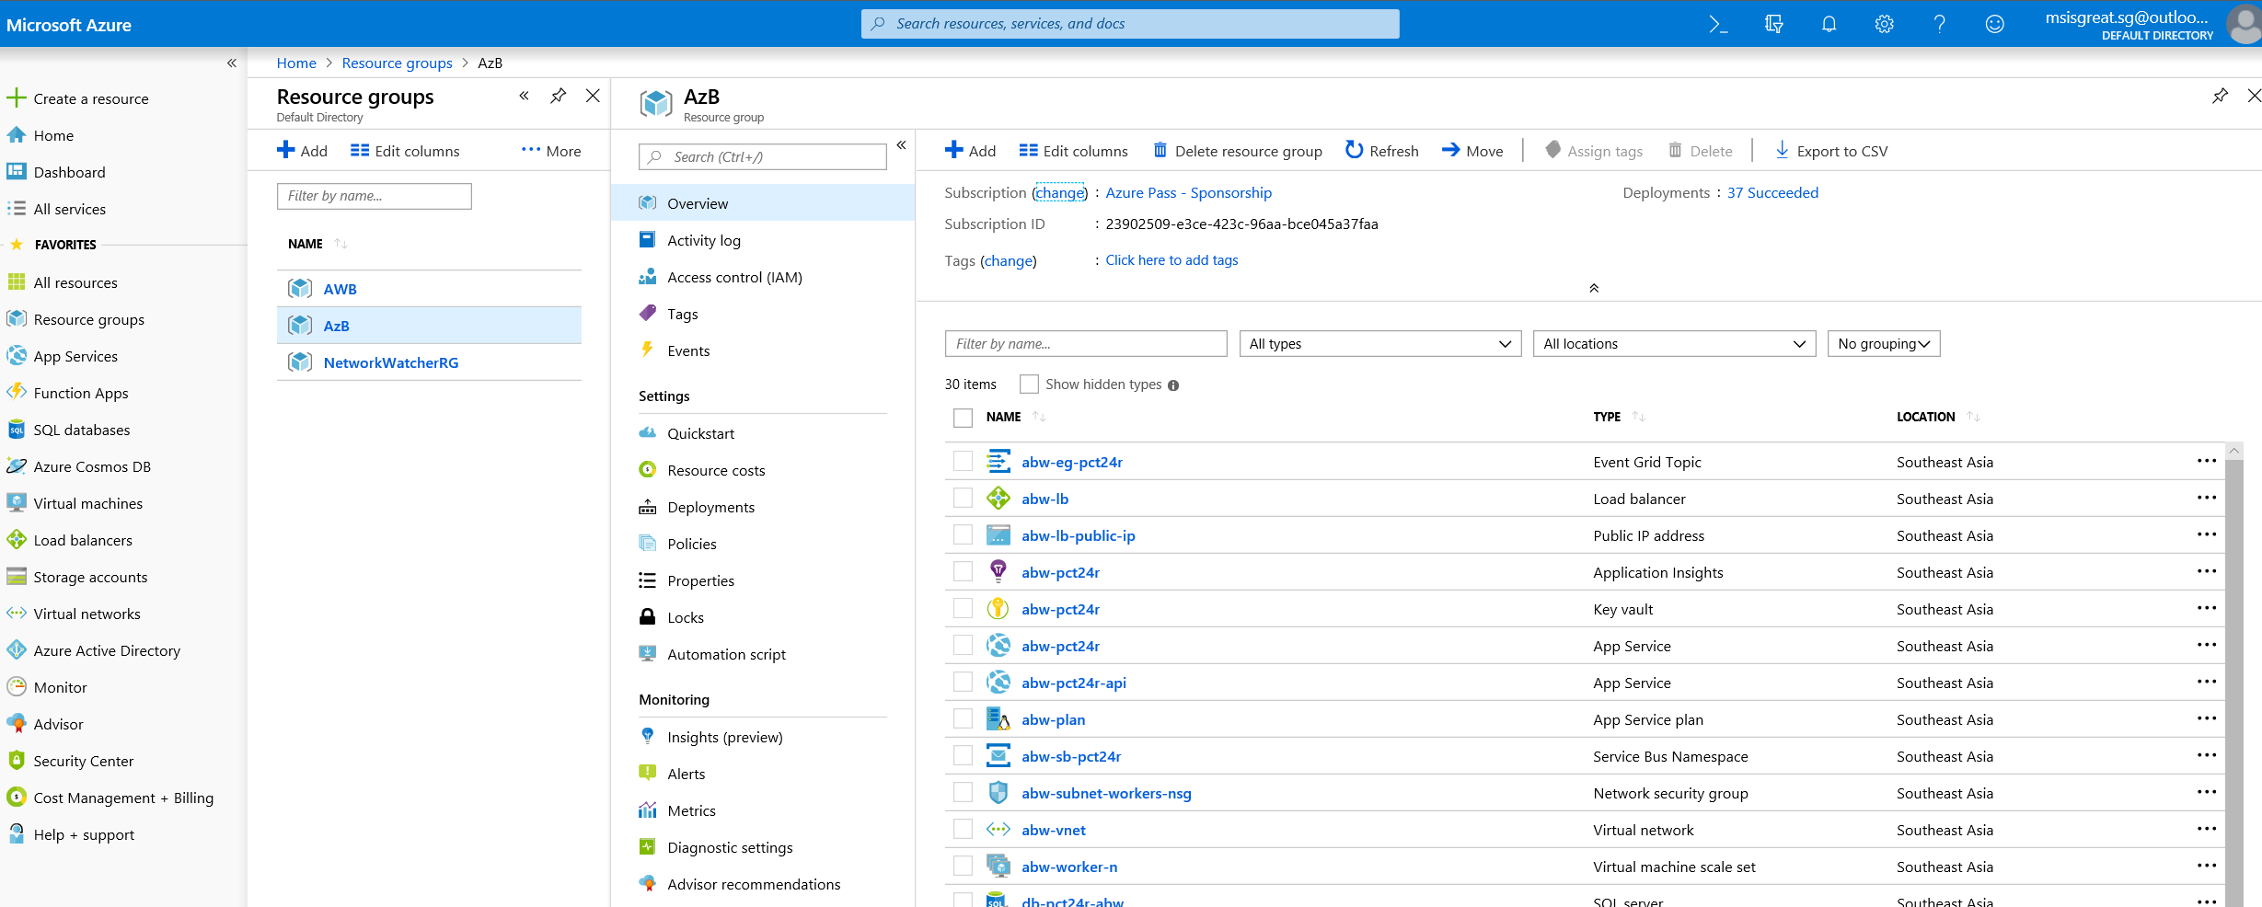

Sort the Type and then to see the web application in the list

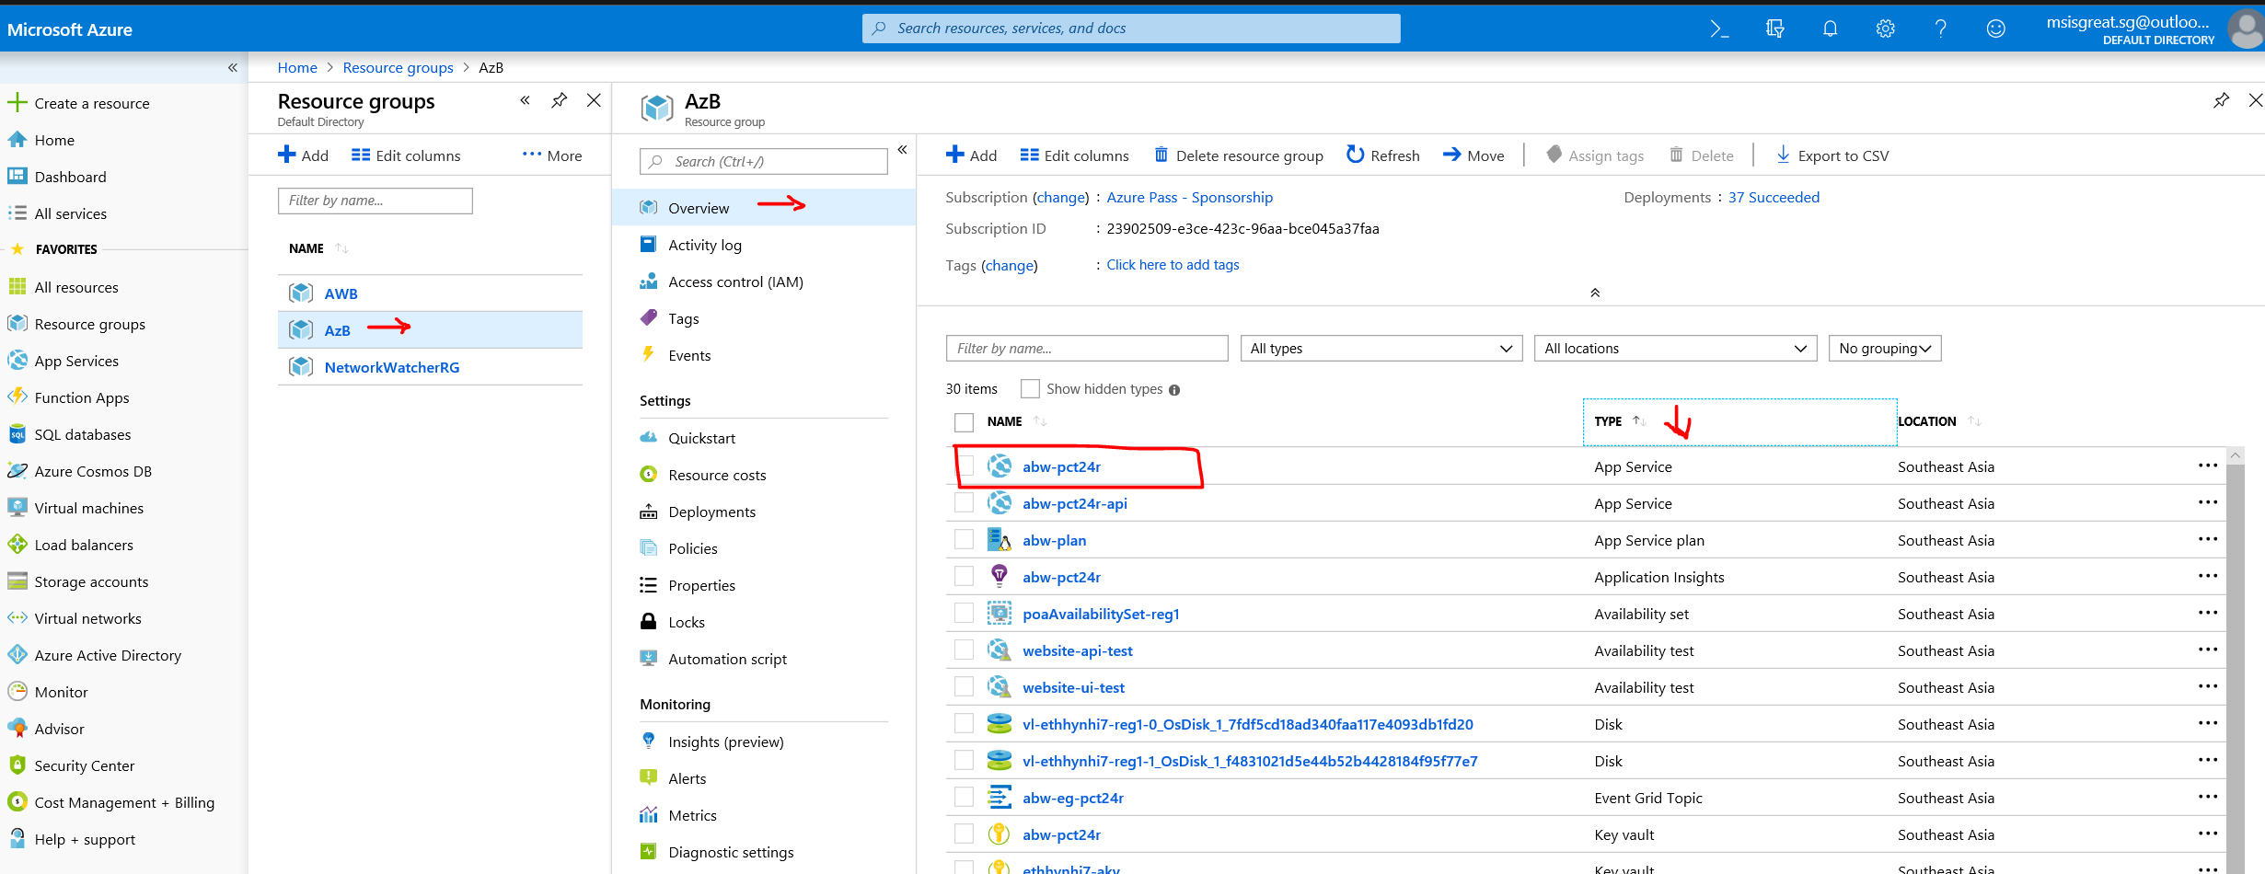

Click on the web application to open the screen below and get the link.

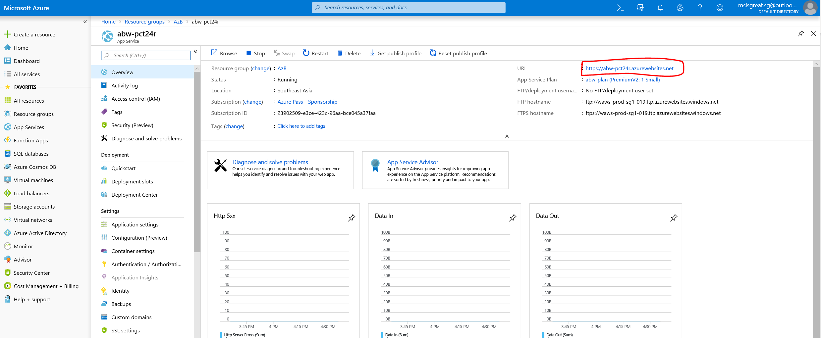

<https://abw-pct24r.azurewebsites.net/>

Navigate to that URL to open the Blockchain Application

# Configuring Blockchain Application

First Navigate to Azure Active Directory to get the AD details

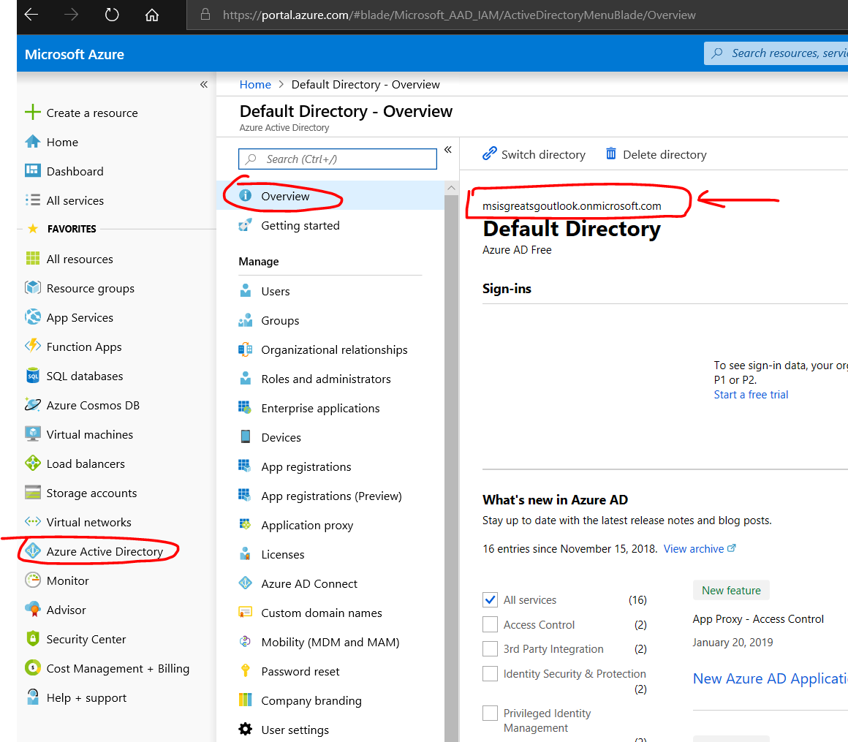

Have that directory name copied to somewhere you might need it later to configure.

## Open the URL which was copied from previous step in the browser

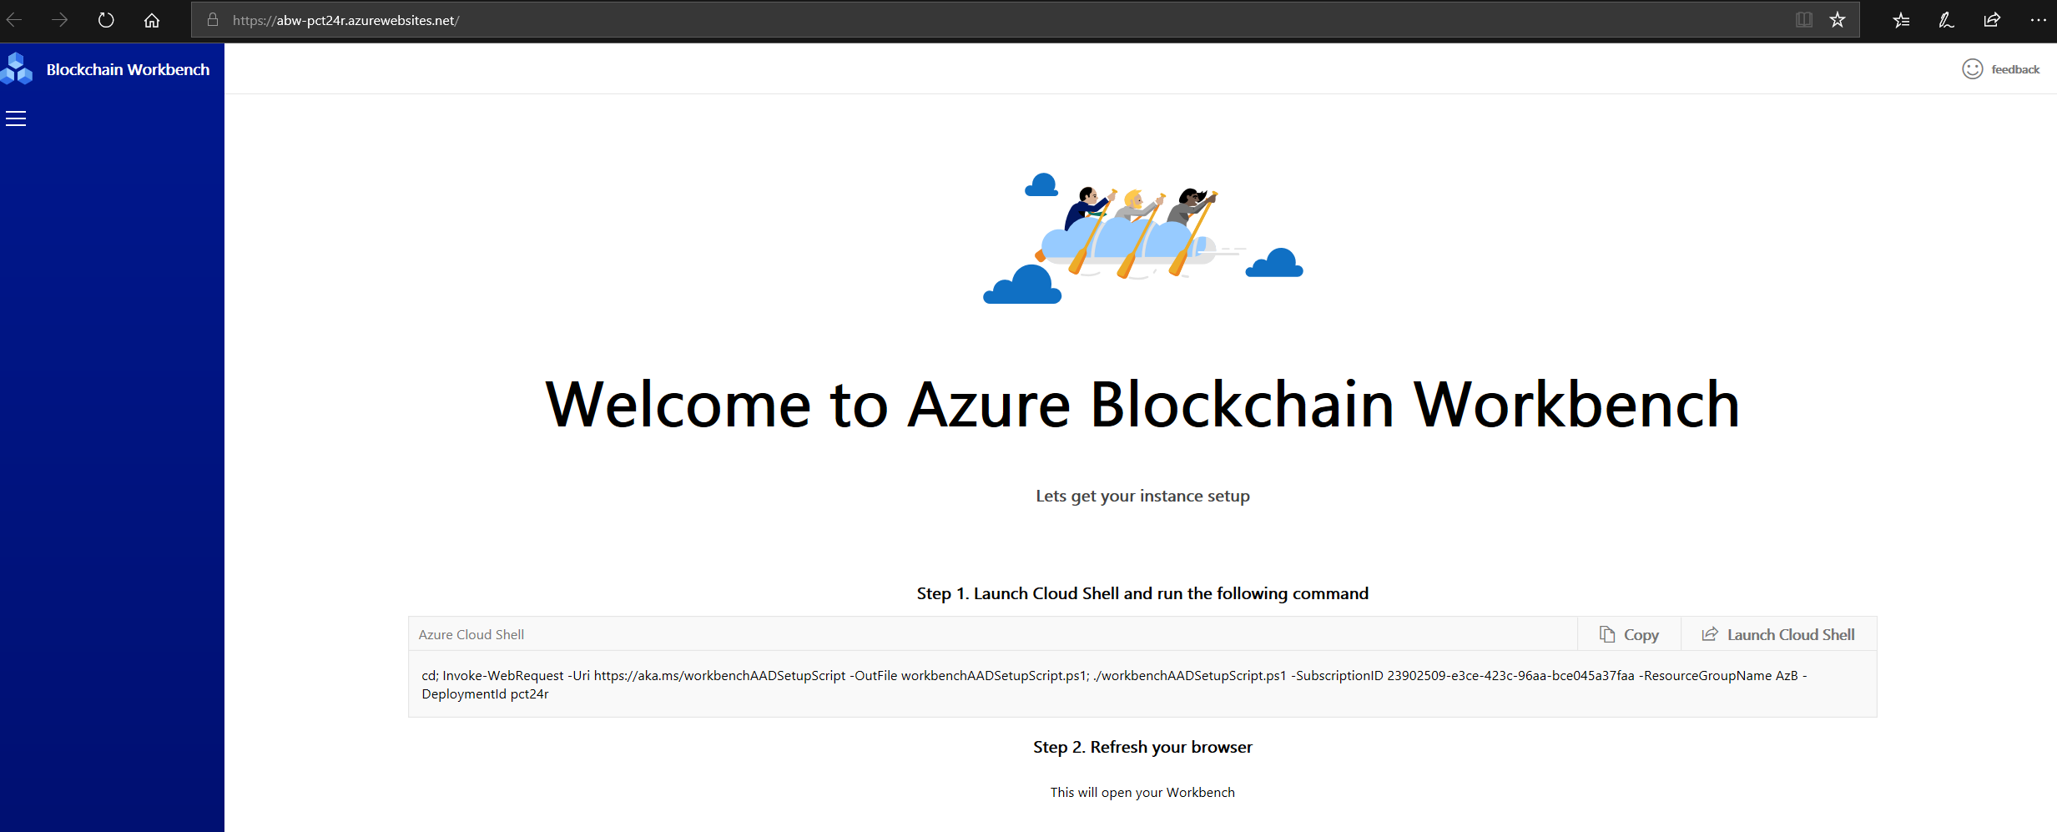

Click on Copy & then Launch Cloud Shell

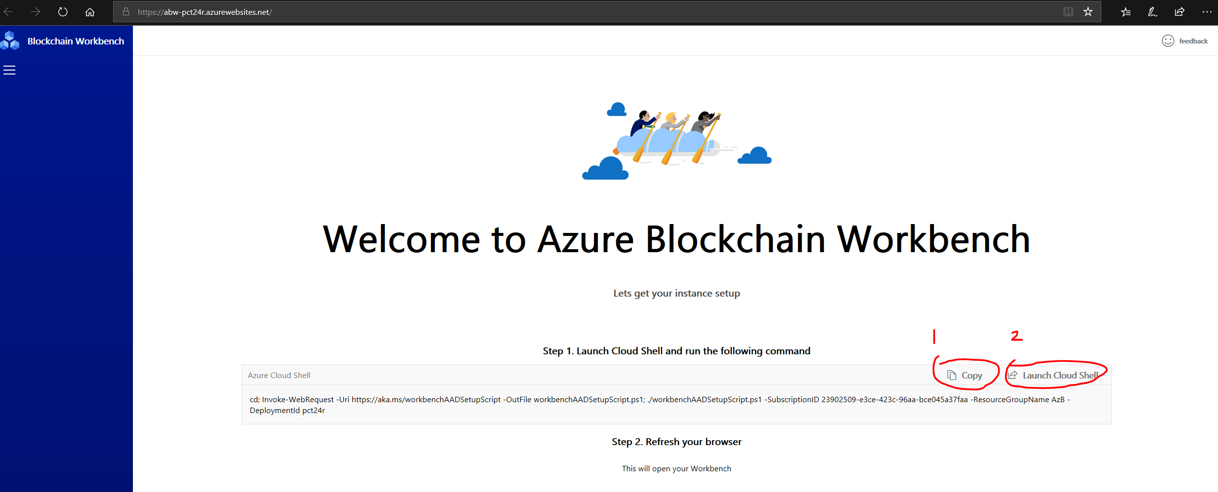

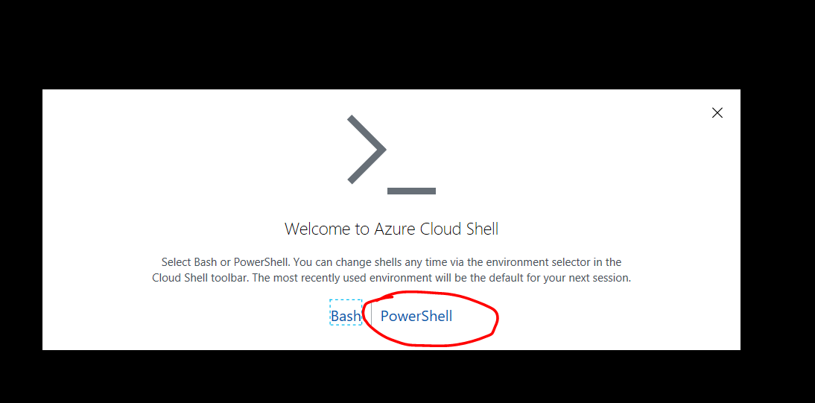

Select PowerShell & if the storage account is not already present the below screen will popup. Click on Create Storage. Sometime if you already have storage account then can choose existing one.

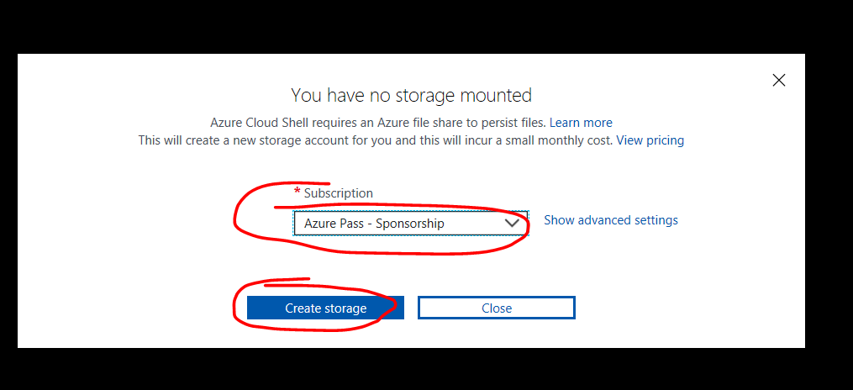

Once created the below screen will open up and ready for input.

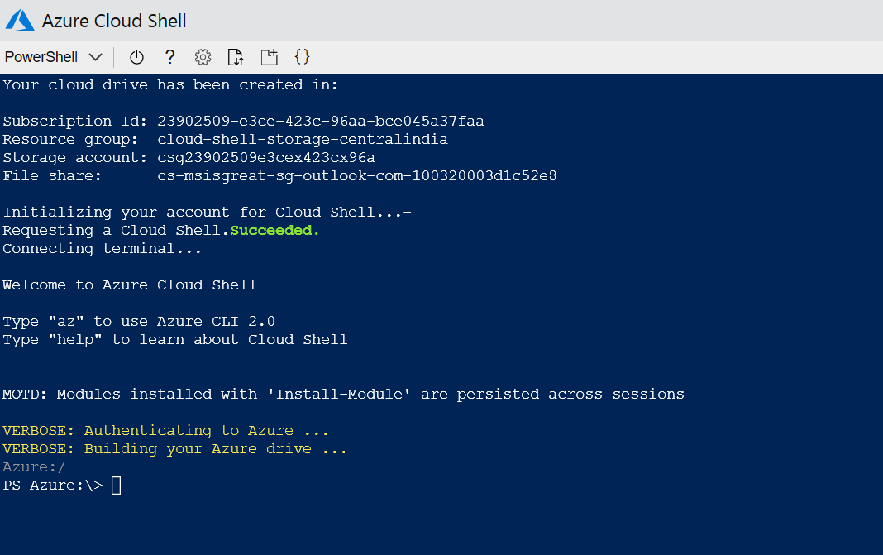

Paste the code you coped in the step before. The screen looks like below

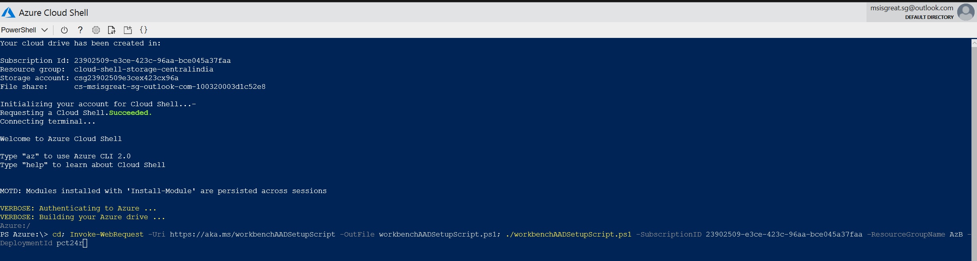

After copy paste press enter to run the script. After script execute you will prompt to enter domain detail. In my case domain is **msisgreatsgoutlook.onmicrosoft.com**

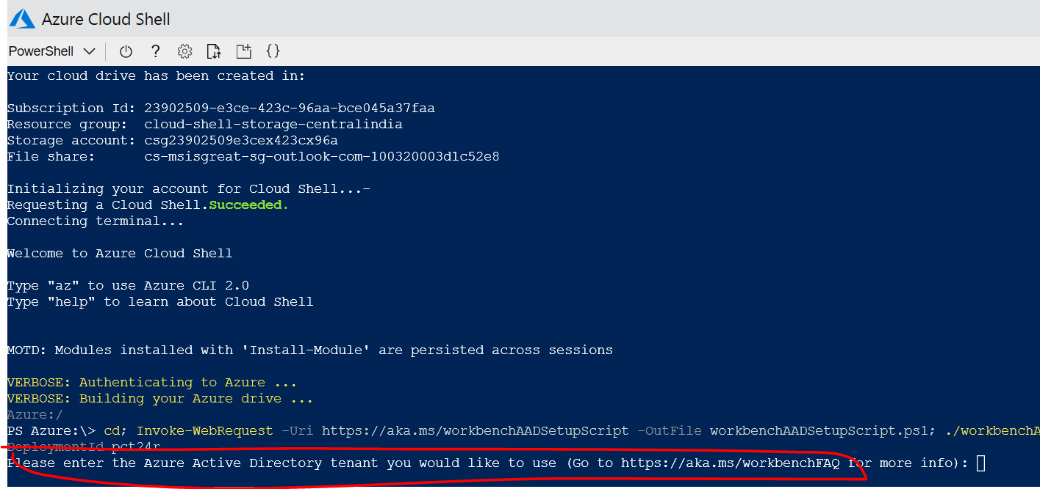

After you enter the directory name press enter

Then you will be given code to authenticate, follow the URL mentioned and type the code to Authenticate

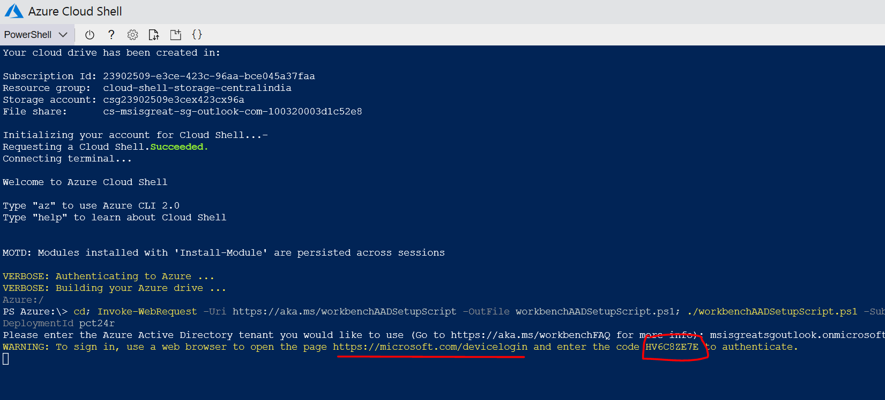

Open the URL <https://microsoft.com/devicelogin>

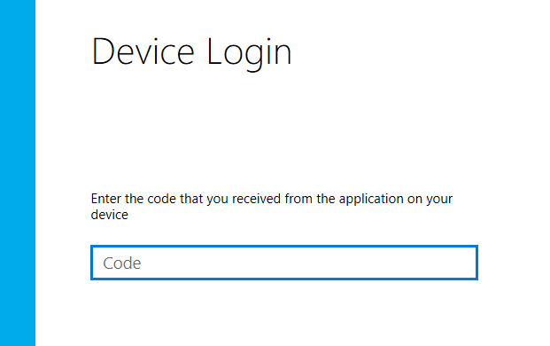

Type the code which is from previous step on the PowerShell screen

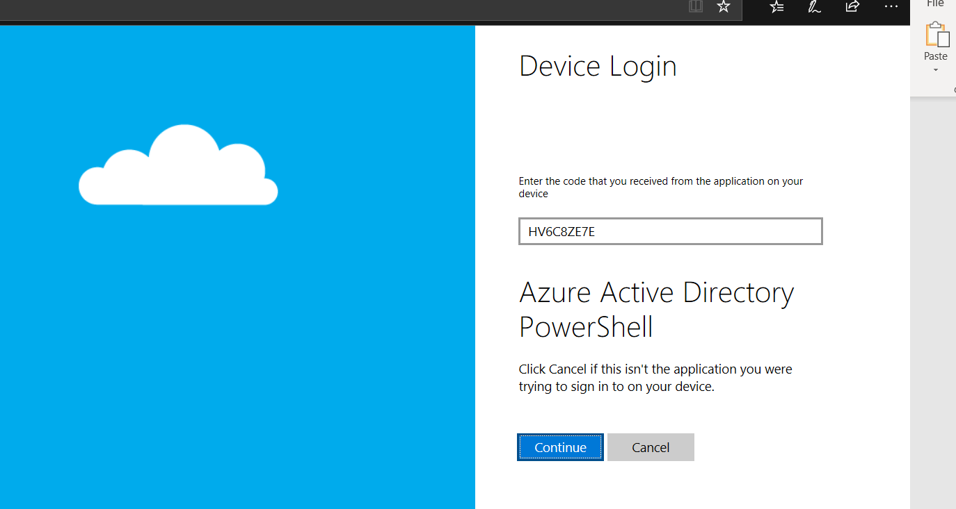

Click Continue

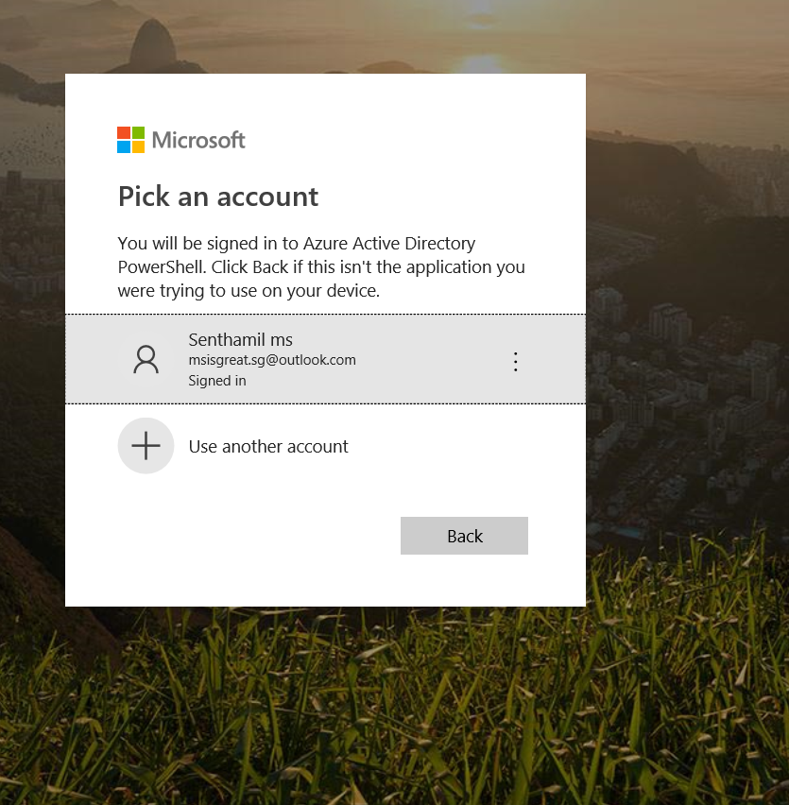

Select the account to login, then close the window after successful login

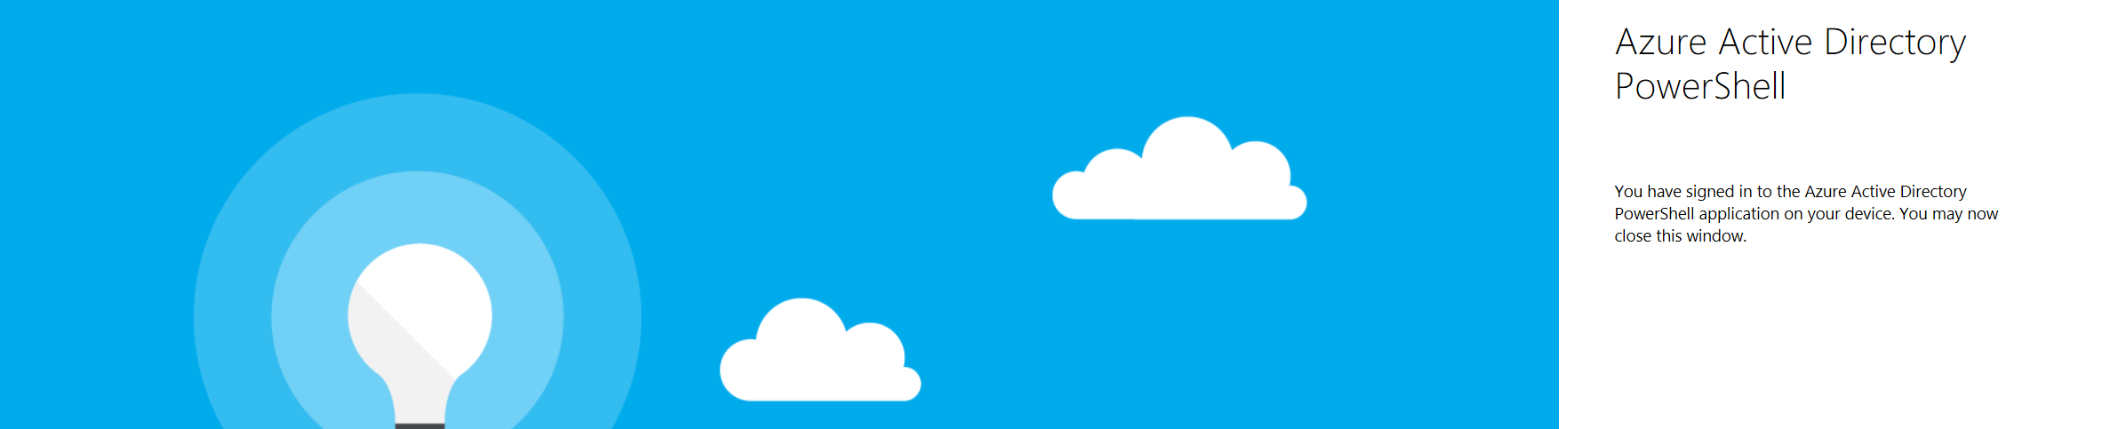

Go back to the PowerShell window now and check the status

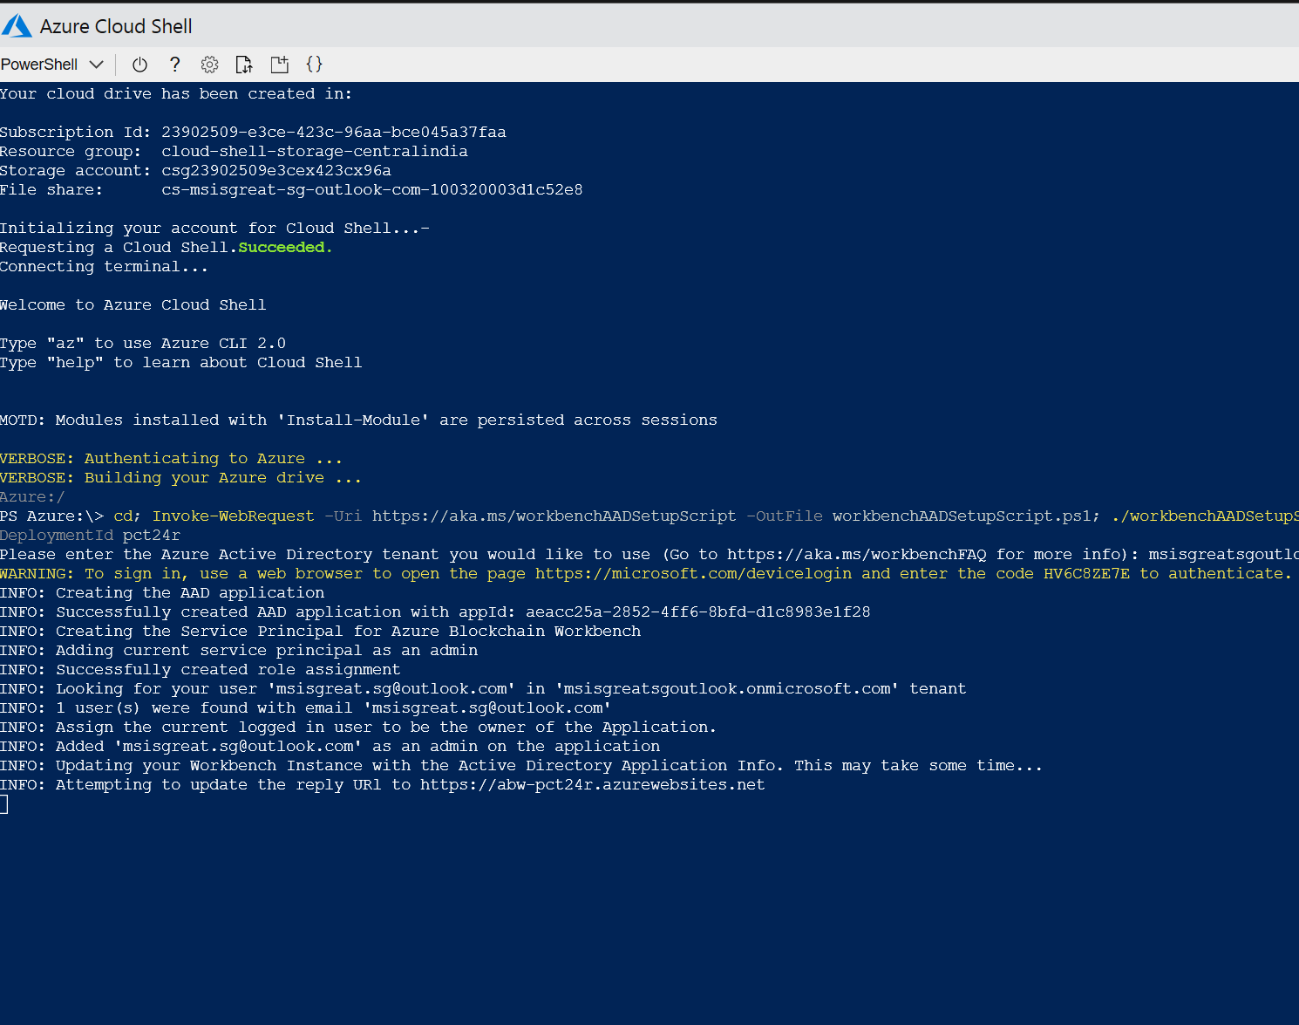

After successful deployment you will get the below message

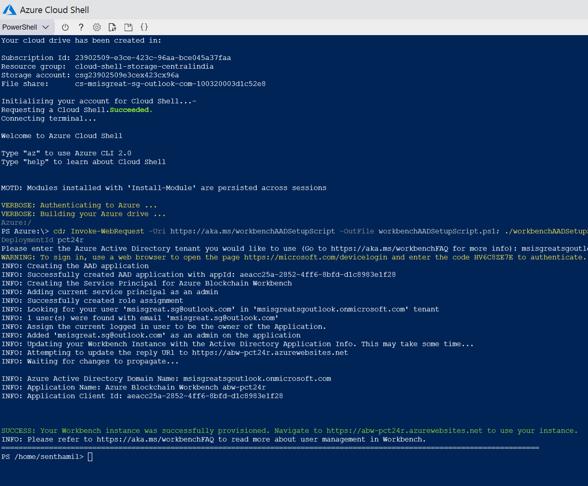

Now go back to the original Blockchain Page



Click on Refresh to show consent

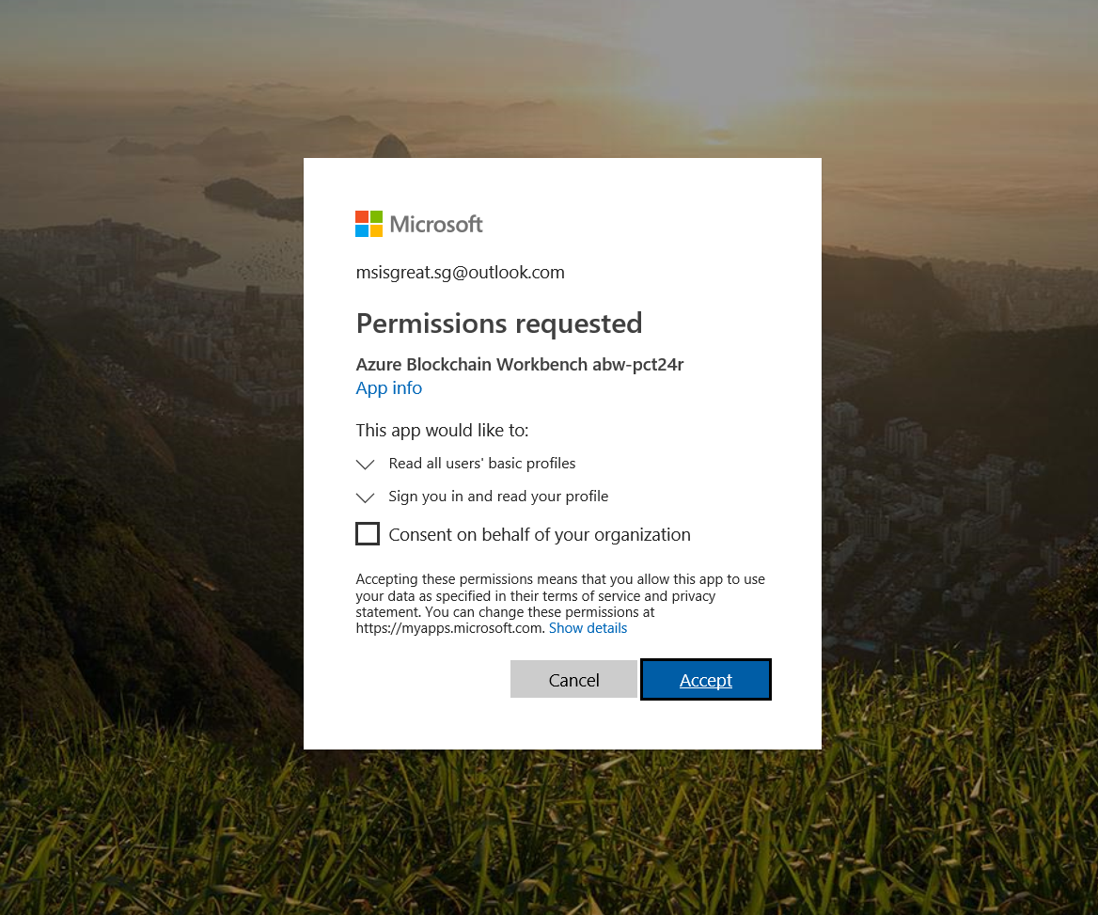

Click Accept on this option

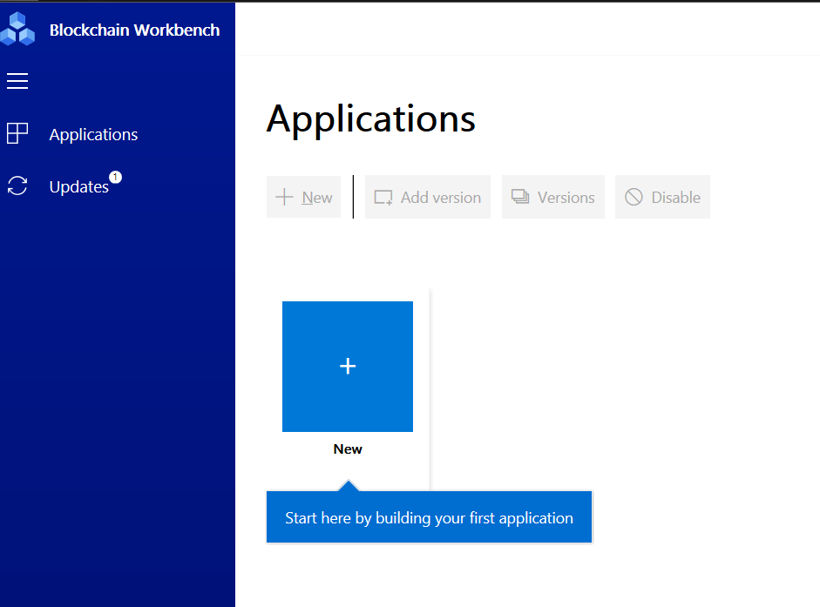

You now successfully created a blank Blockchain Application. Now next need to create a Registration API to get details from User account from AD.

# User API Registration

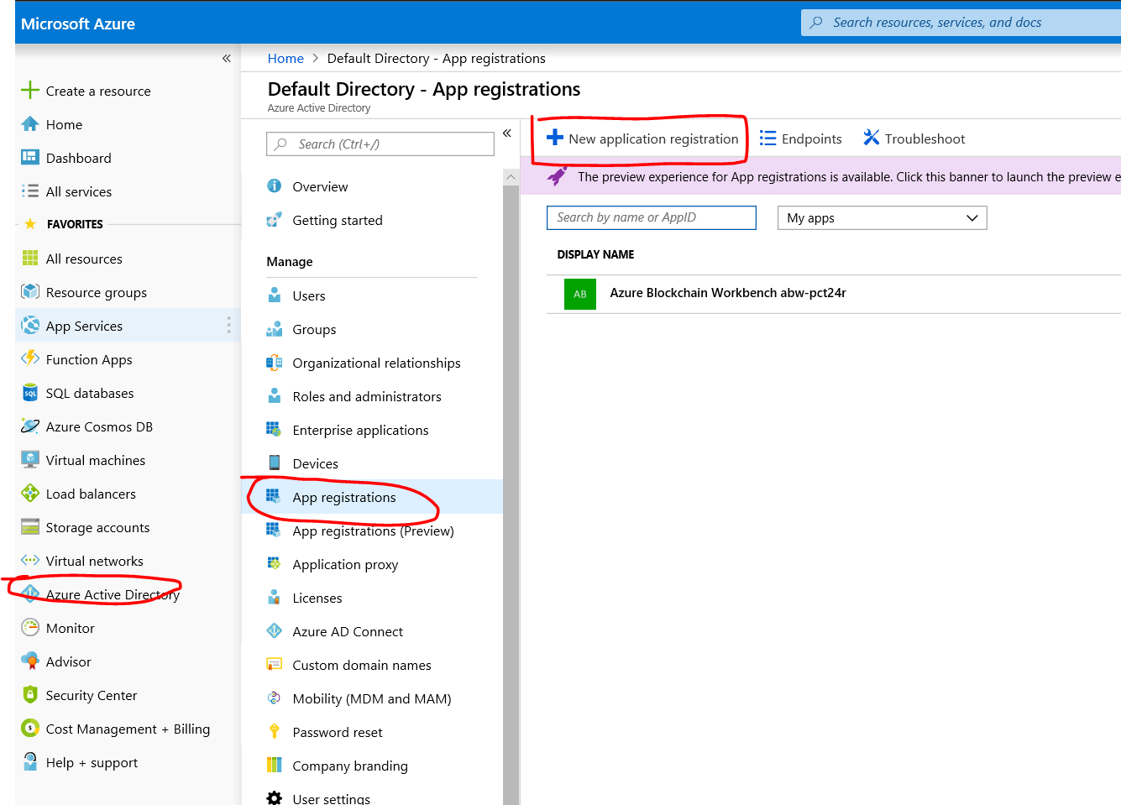

In the New Application Registration enter the below screen details.

Name: Blockchain API

URL: <https://blockchainapi>

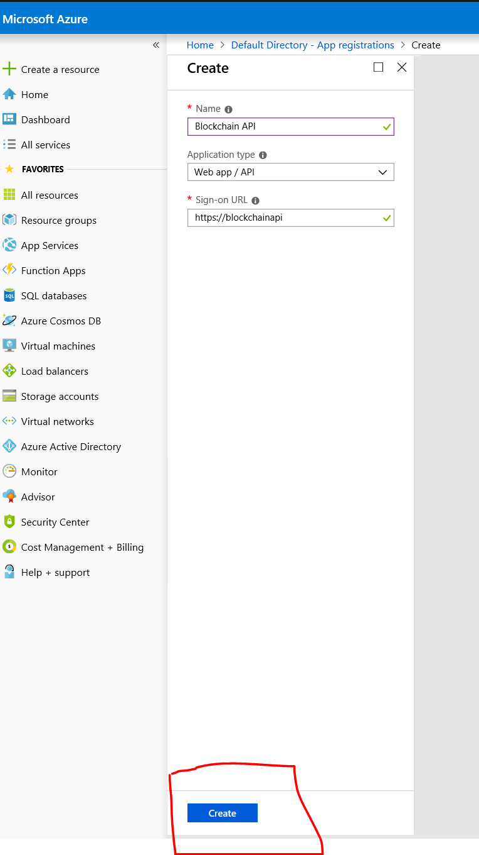

Click on create button after finish entering details as in above screen.

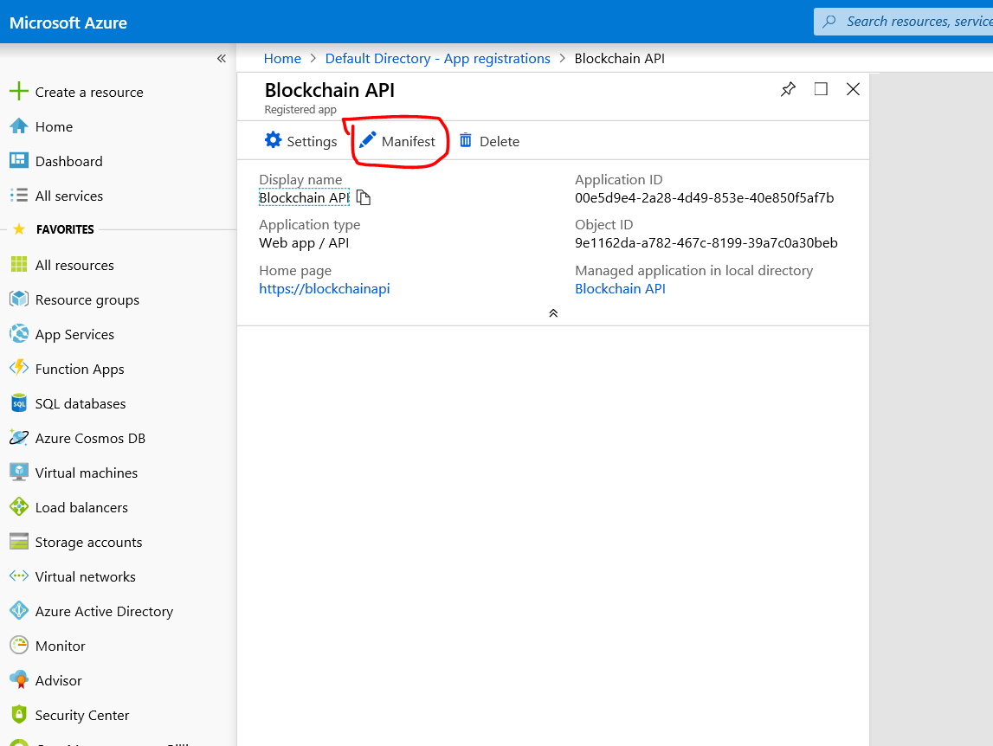

Edit the appRoles section of the manifest

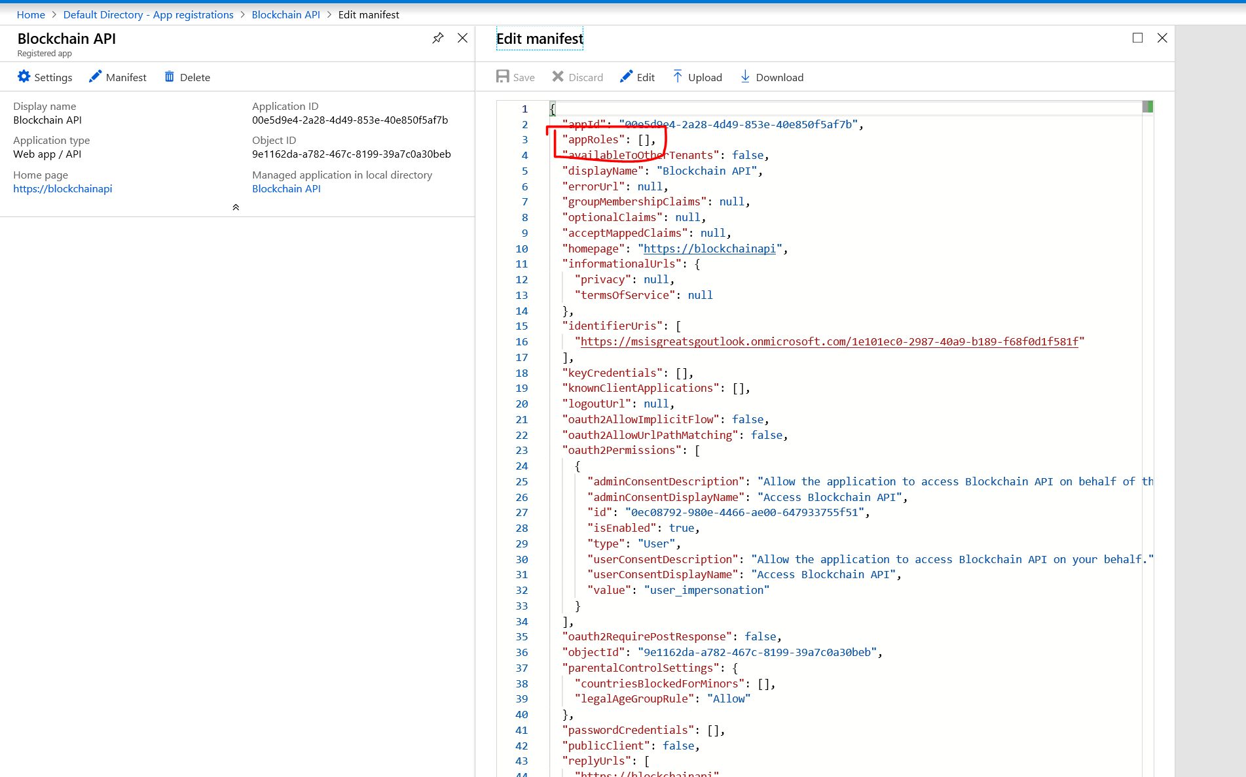

Copy this text

"appRoles": [

{

"allowedMemberTypes": [

"User",

"Application"

],

"displayName": "Administrator",

"id": "<A unique GUID>",

"isEnabled": true,

"description": "Blockchain Workbench administrator role allows creation of applications, user to role assignments, etc.",

"value": "Administrator"

}

],

After paste into the manifest should look like below

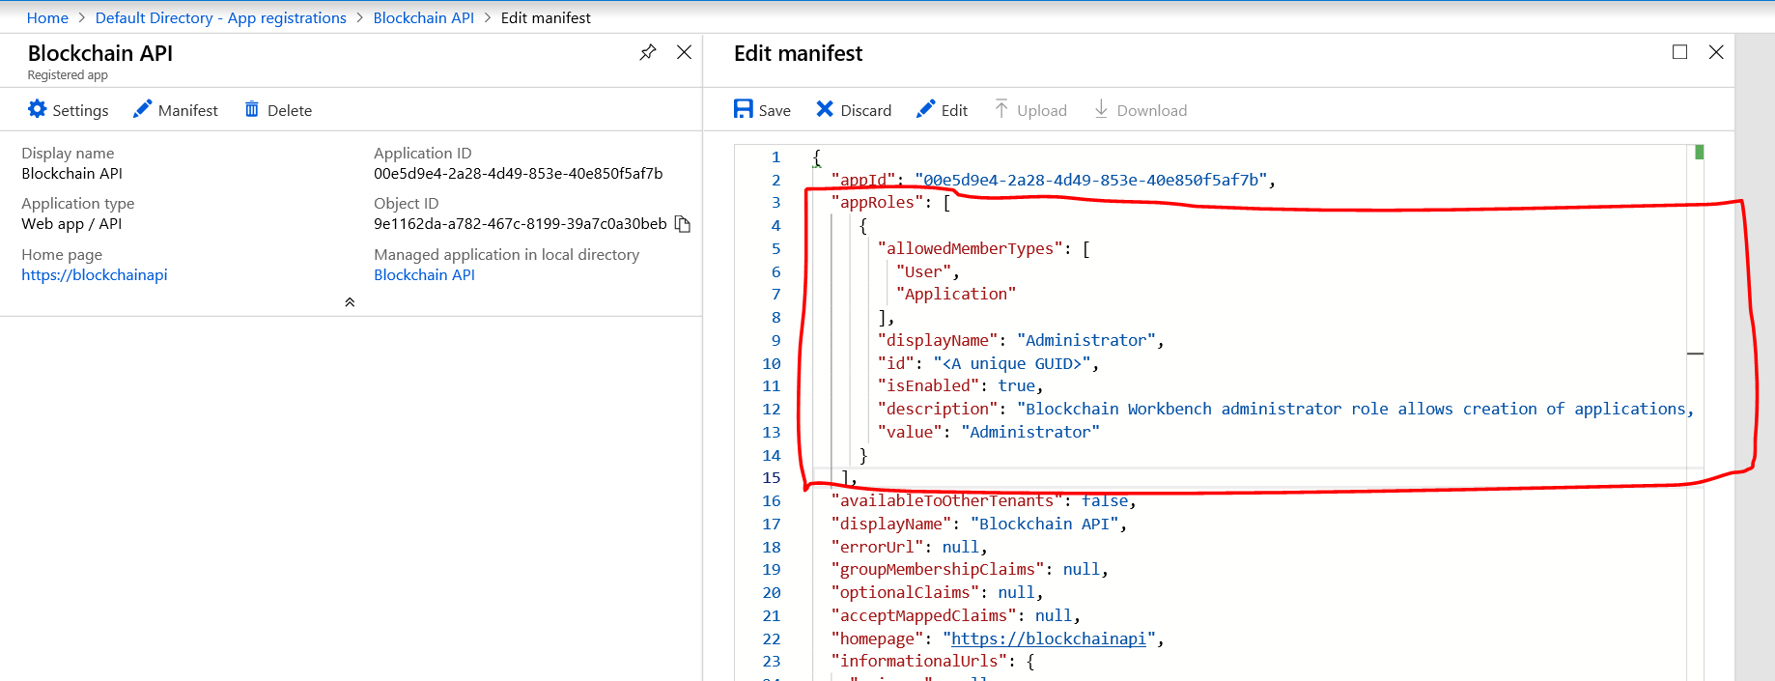

In the Manifest change the **Oauth2AllowImplicitFlow** value to true.

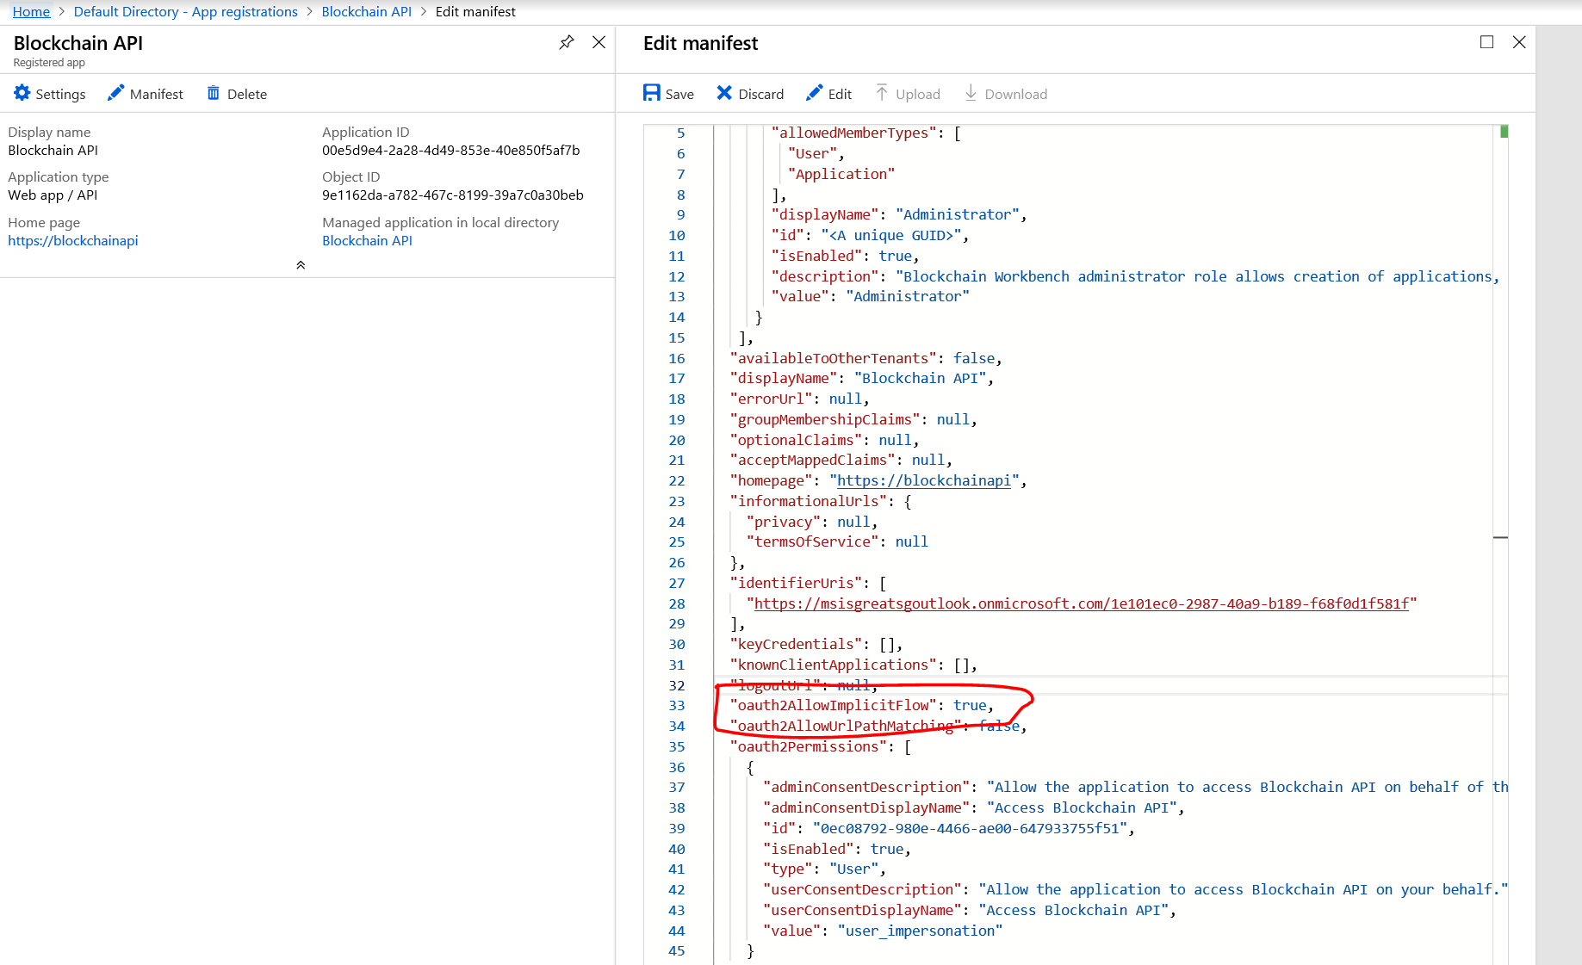

Generate a GUID to be added to the Application. It can be any GUID generator. I use PowerShell to generate. If you don’t have Windows Machine / Powershell ask your friend to help you generate. Any GUID generated from other machine can be used too.

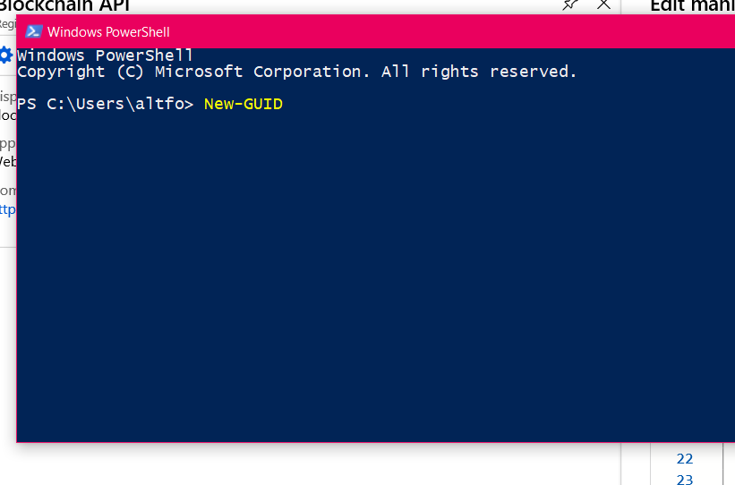

My GUID is ad8cc7b7-0dfe-4916-9eaa-b952c74ae78c

You can also try use this GUID

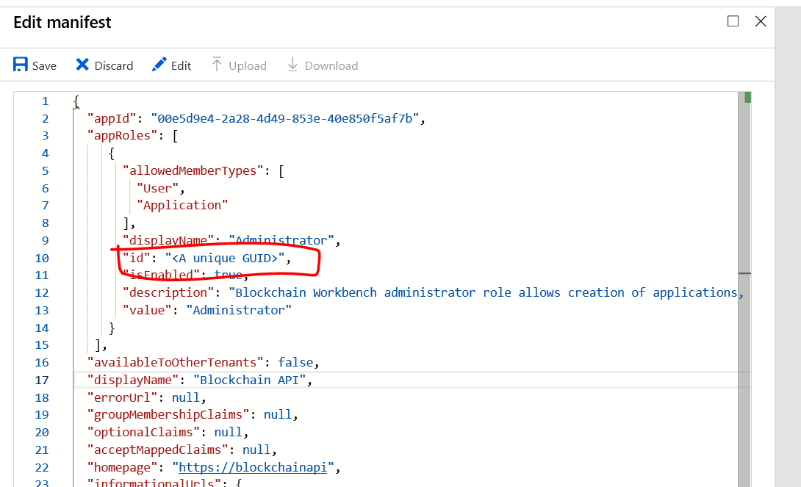

Replace that with the GUID generated “ad8cc7b7-0dfe-4916-9eaa-b952c74ae78c”

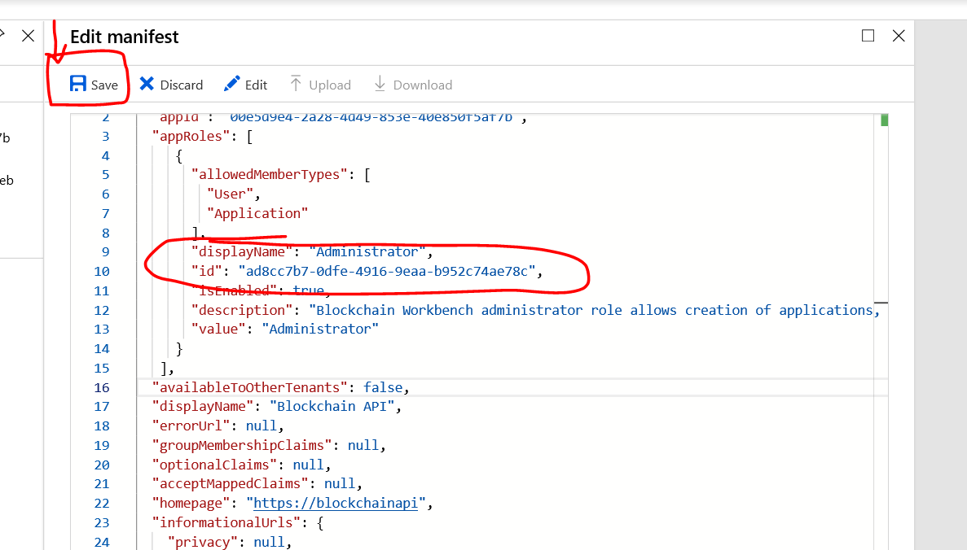

Once you entered Press Save at top.

Click on Settings then the Required Permissions. Follow the order by number on the click as in screen below and finally click select

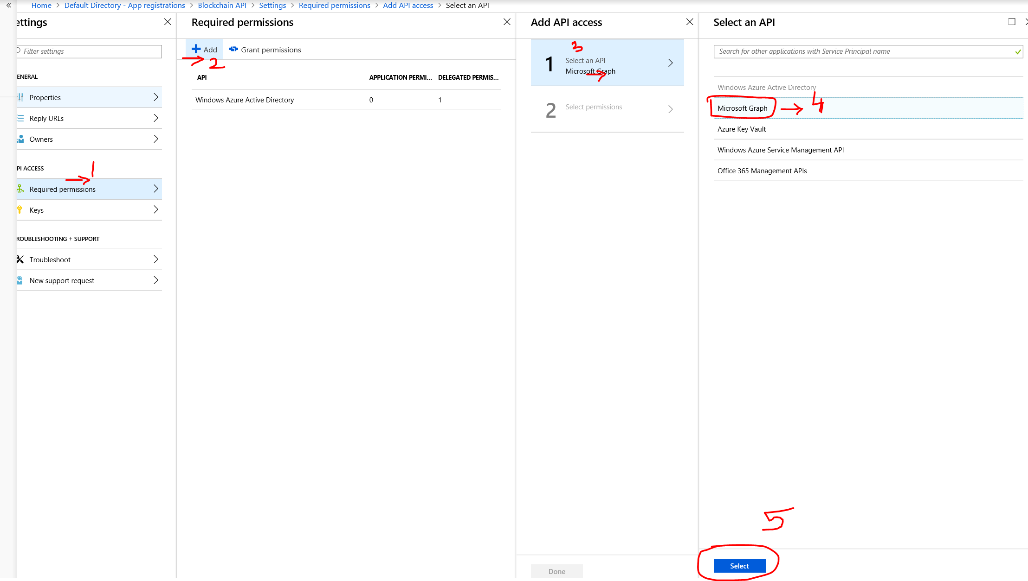

Once selected then Scroll Enable access option to Delegated Permissions

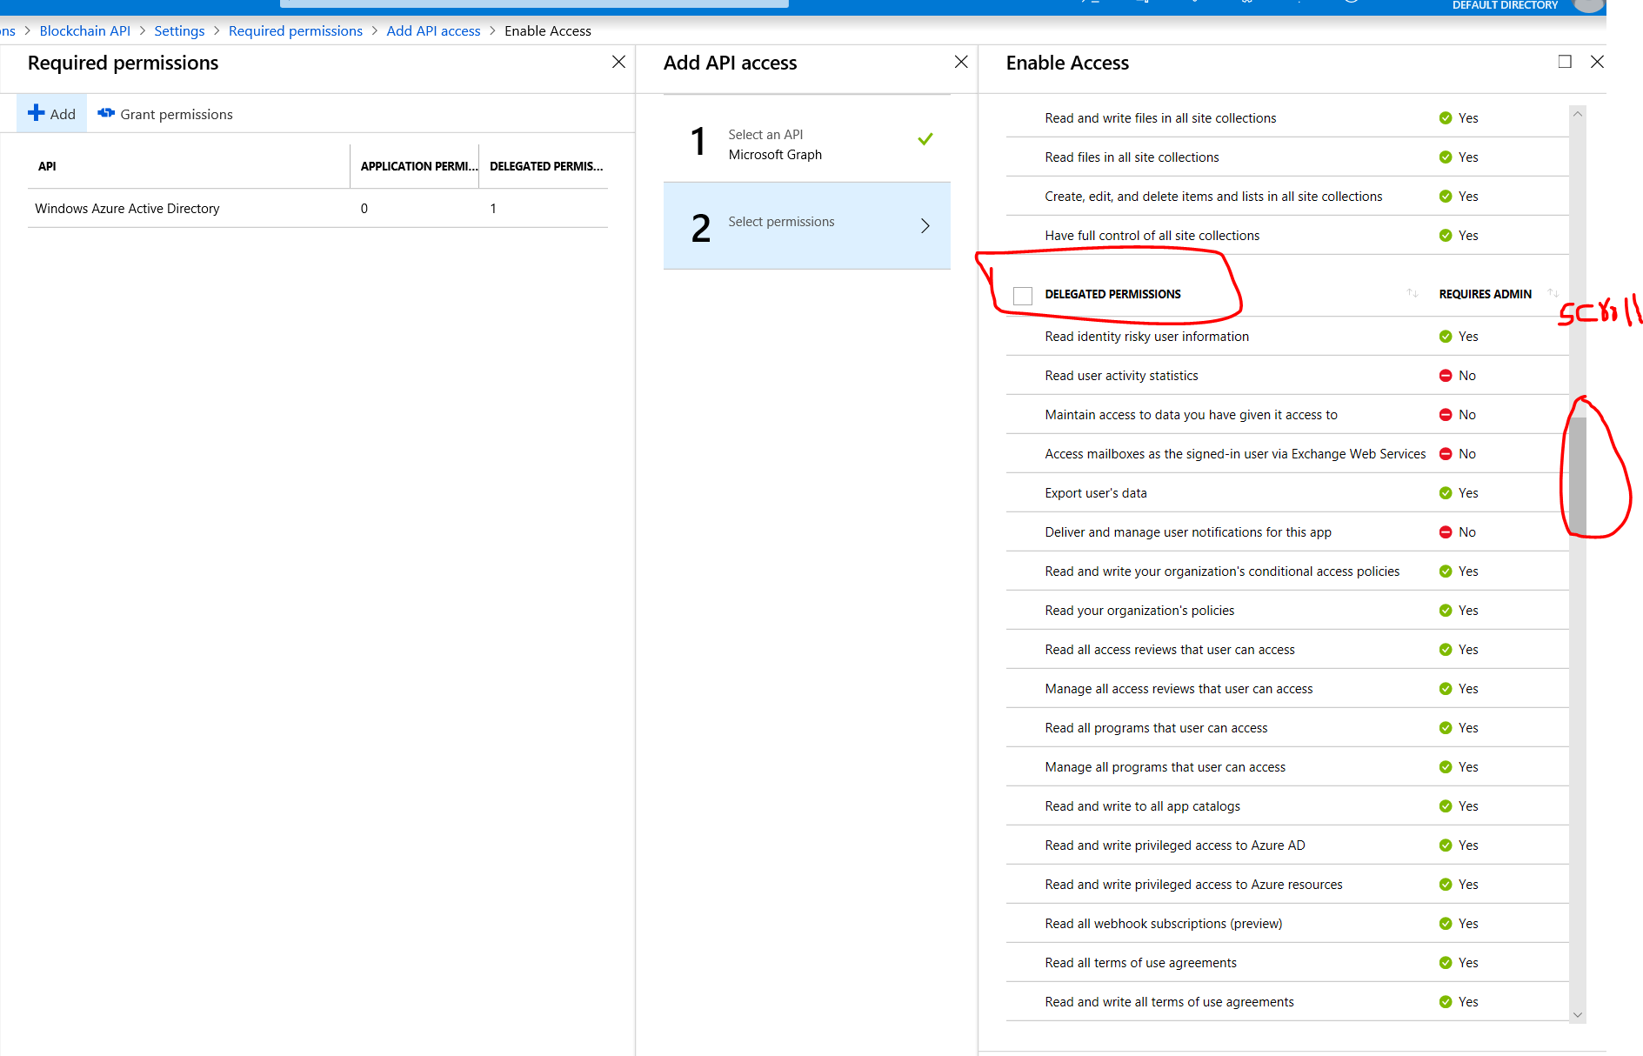

Look for **Read all users' basic profiles, tick the checkbox and Select button at bottom**

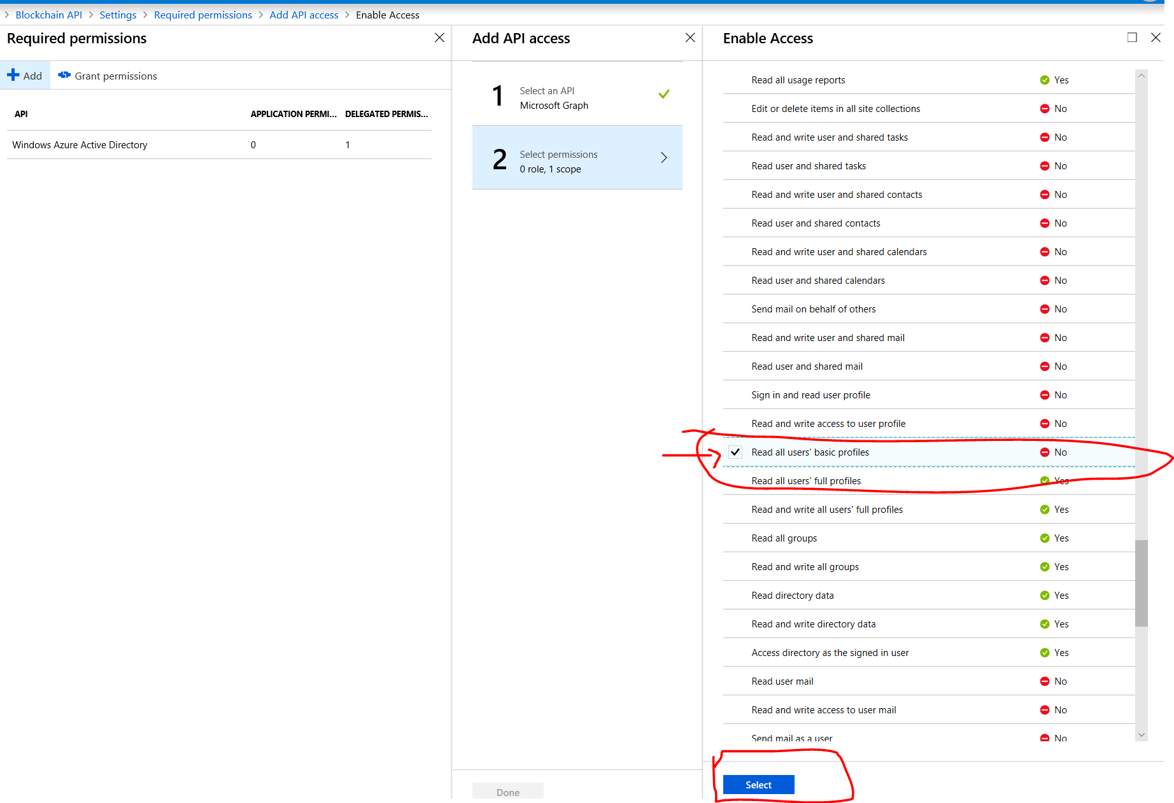

Then click on Done

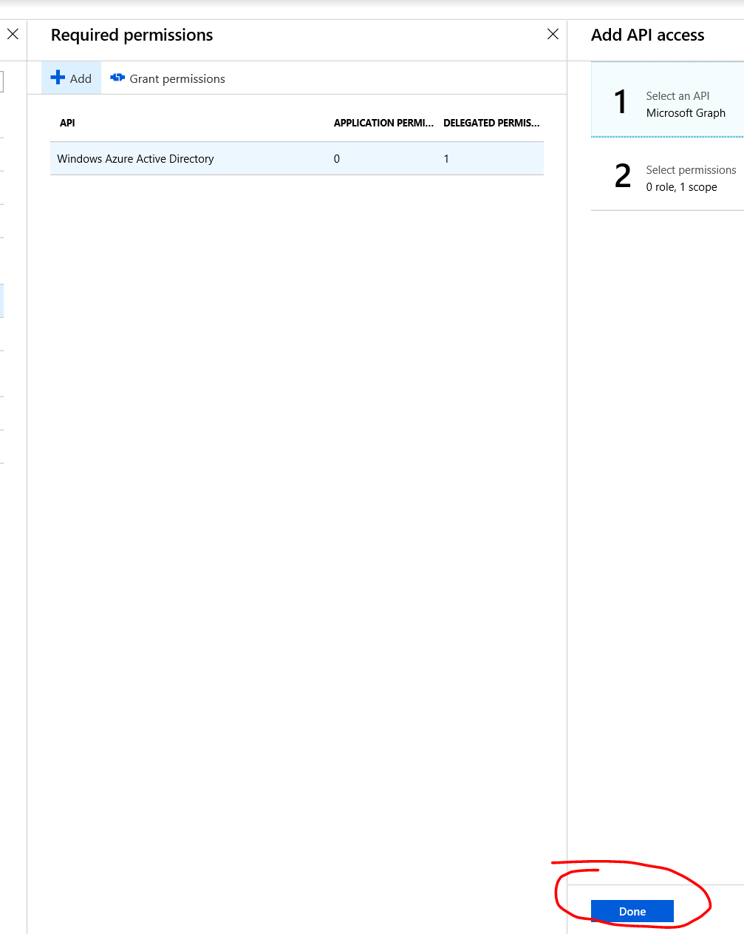

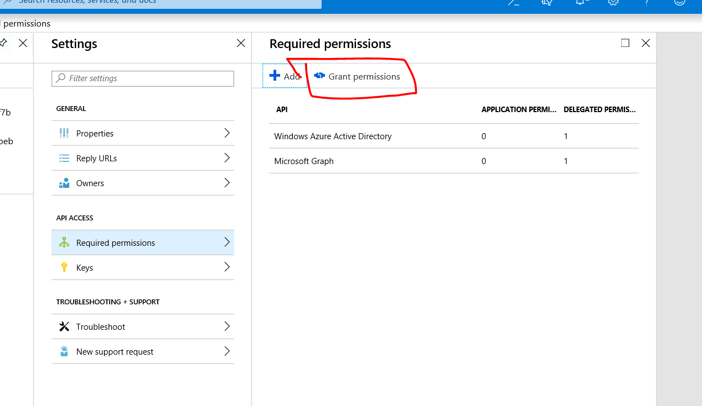

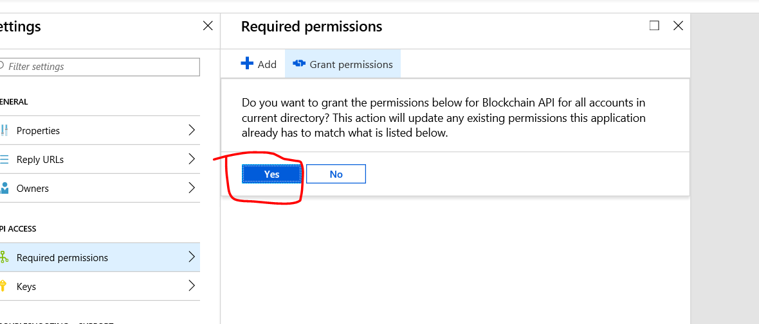

Now go back to the Azure Active Directory and click on User Settings

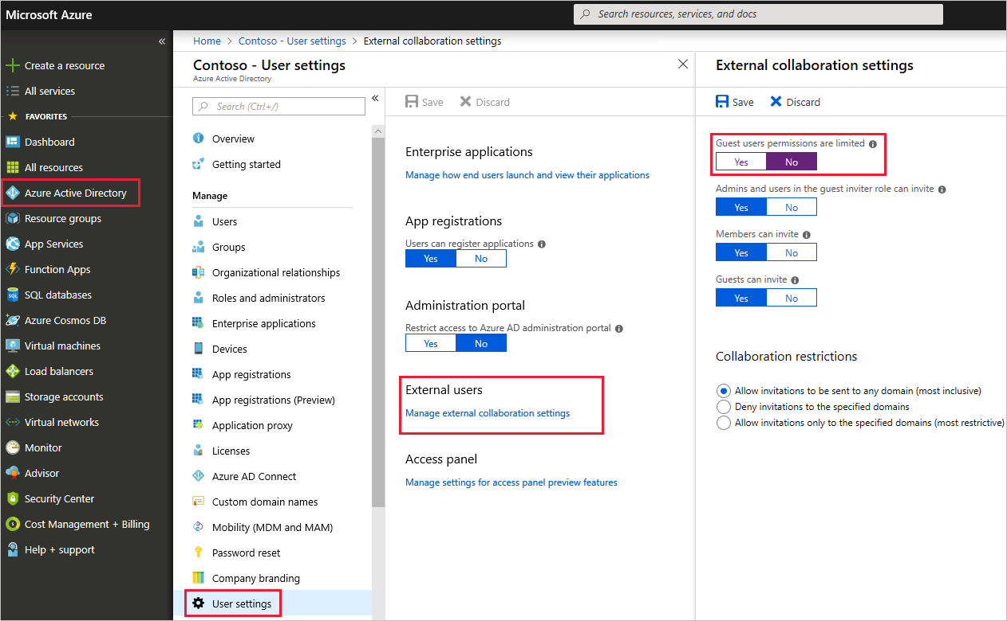

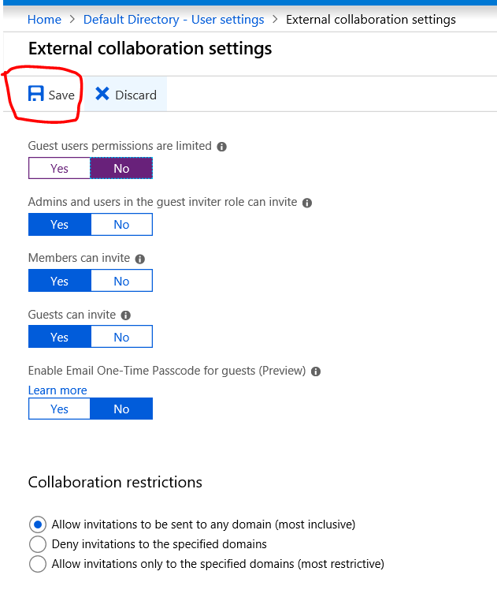

## Configuring Reply URL

Go back to the Azure Active Directory Click on App registrations then on right side select All apps and you can see Blockchain API. Select that

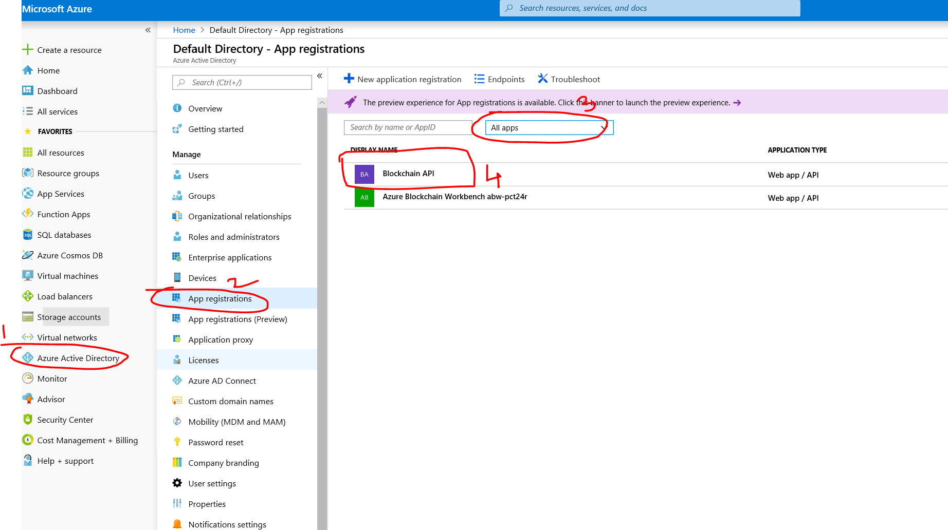

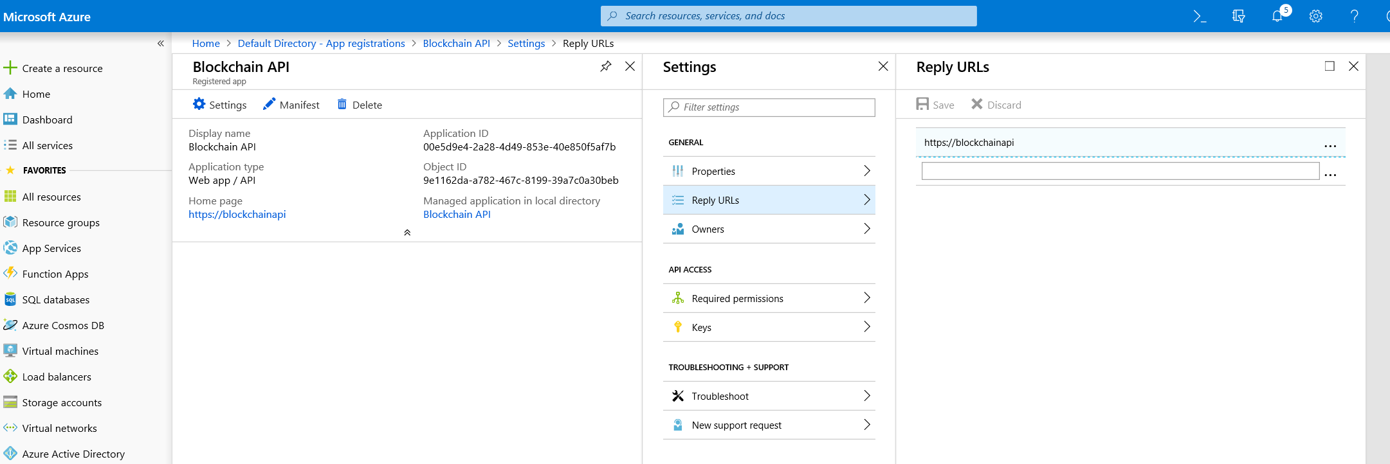

In the reply URL you need to enter the URL of the Blockchain App

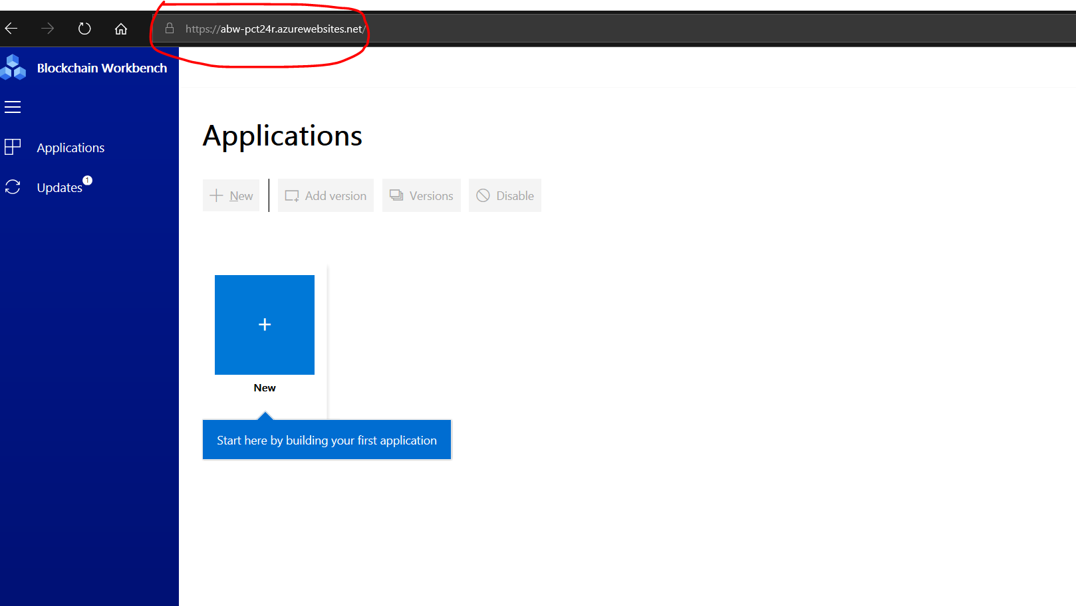

After modifying the existing entry it look like this below

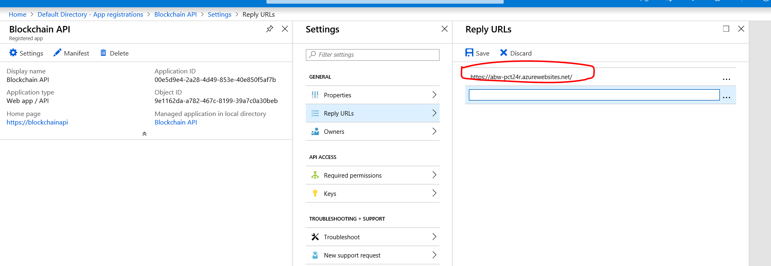

Click On Save Button

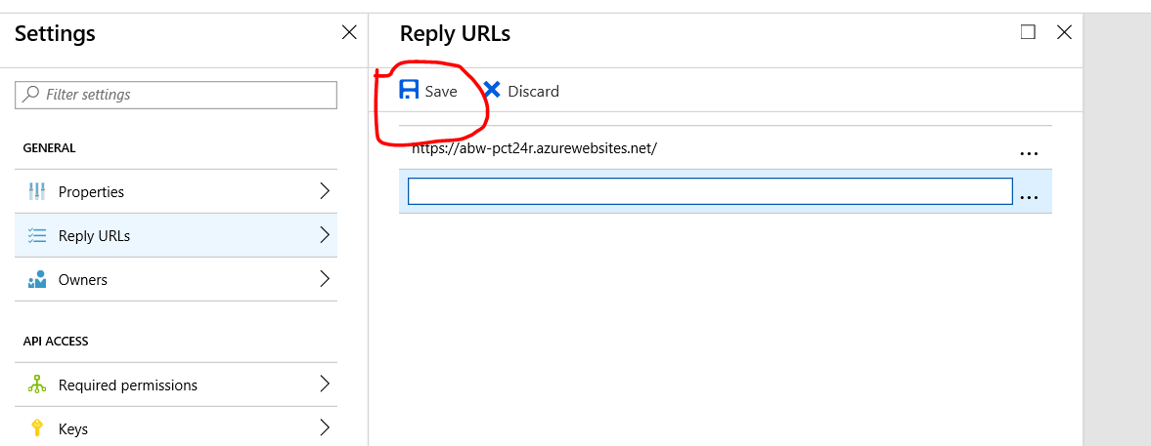

## Setting User Permission as Admin

Go back to Azure Active Directory and click on Enterprise Applications

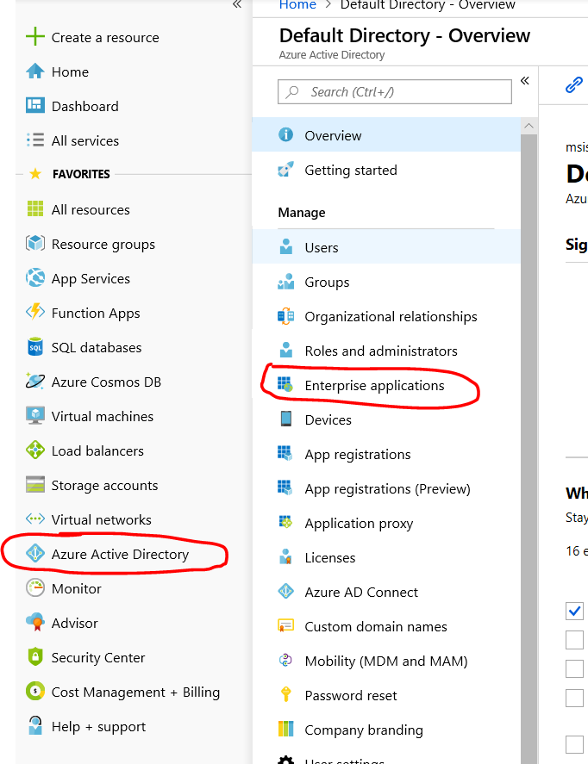

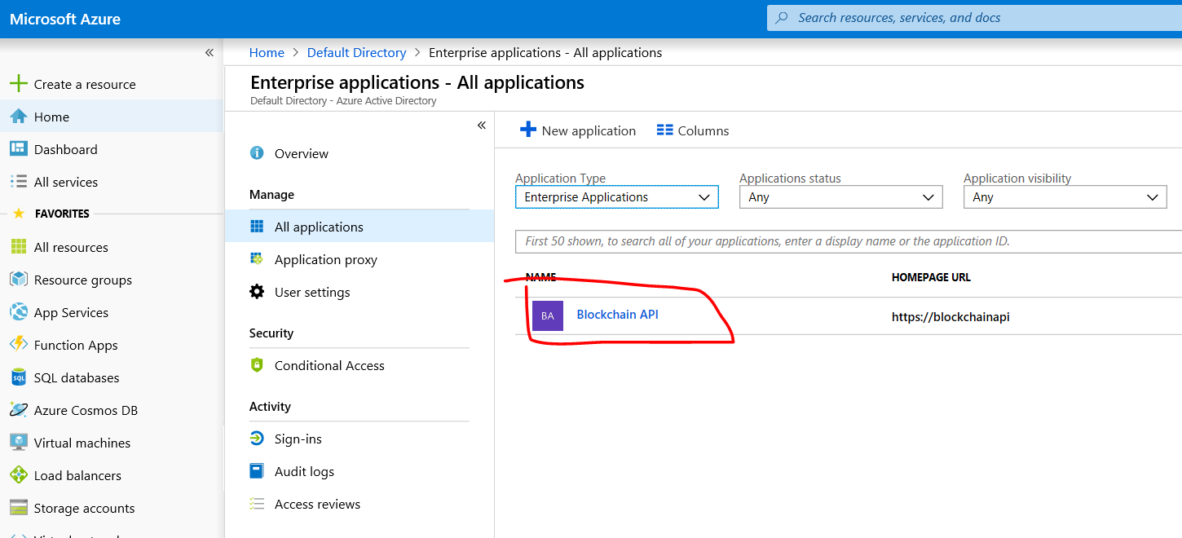

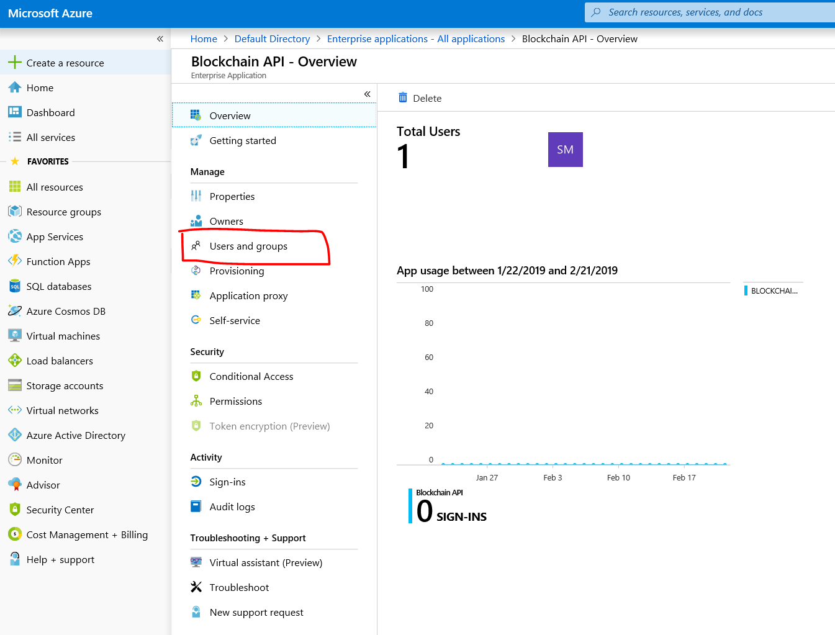

Select the user and check the box and click on edit

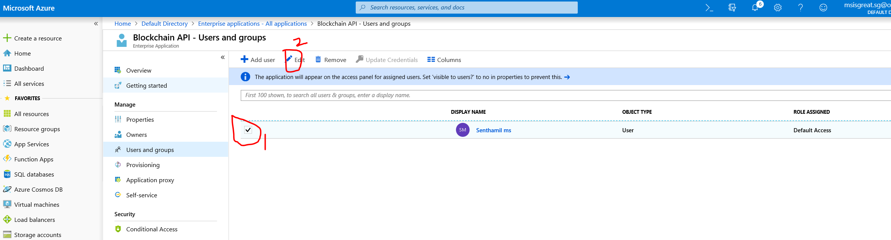

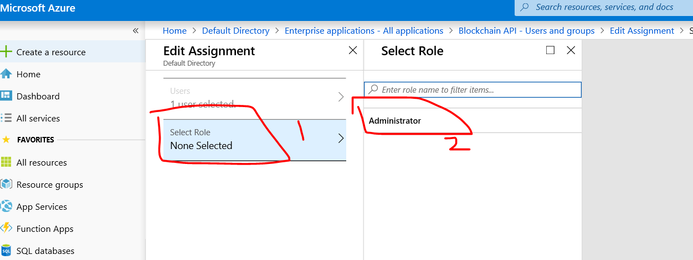

After selecting Administrator click on Select

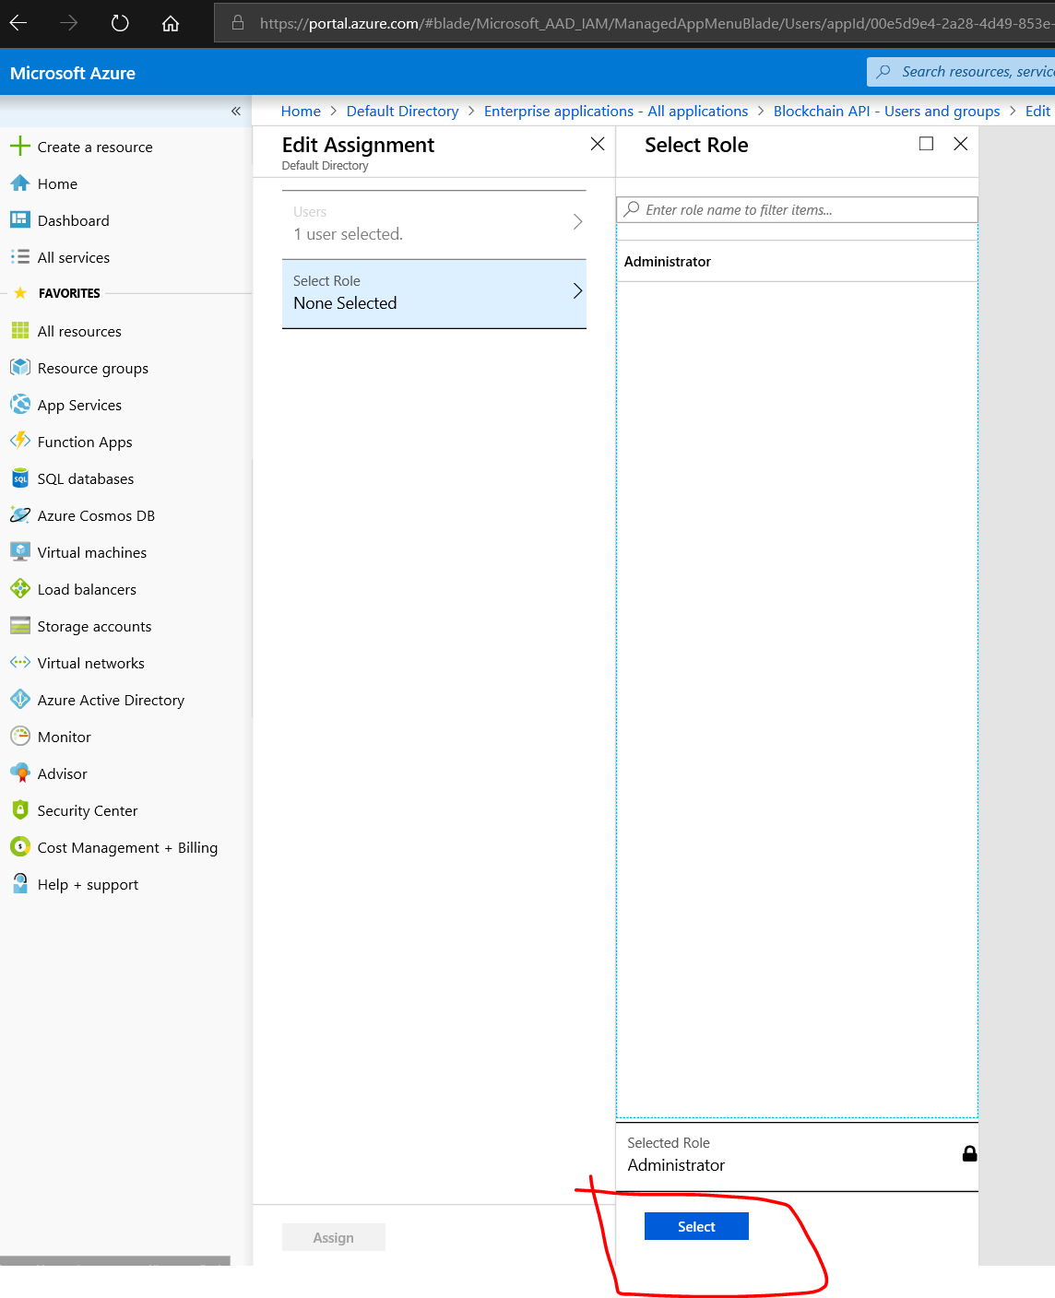

Then click on Assign

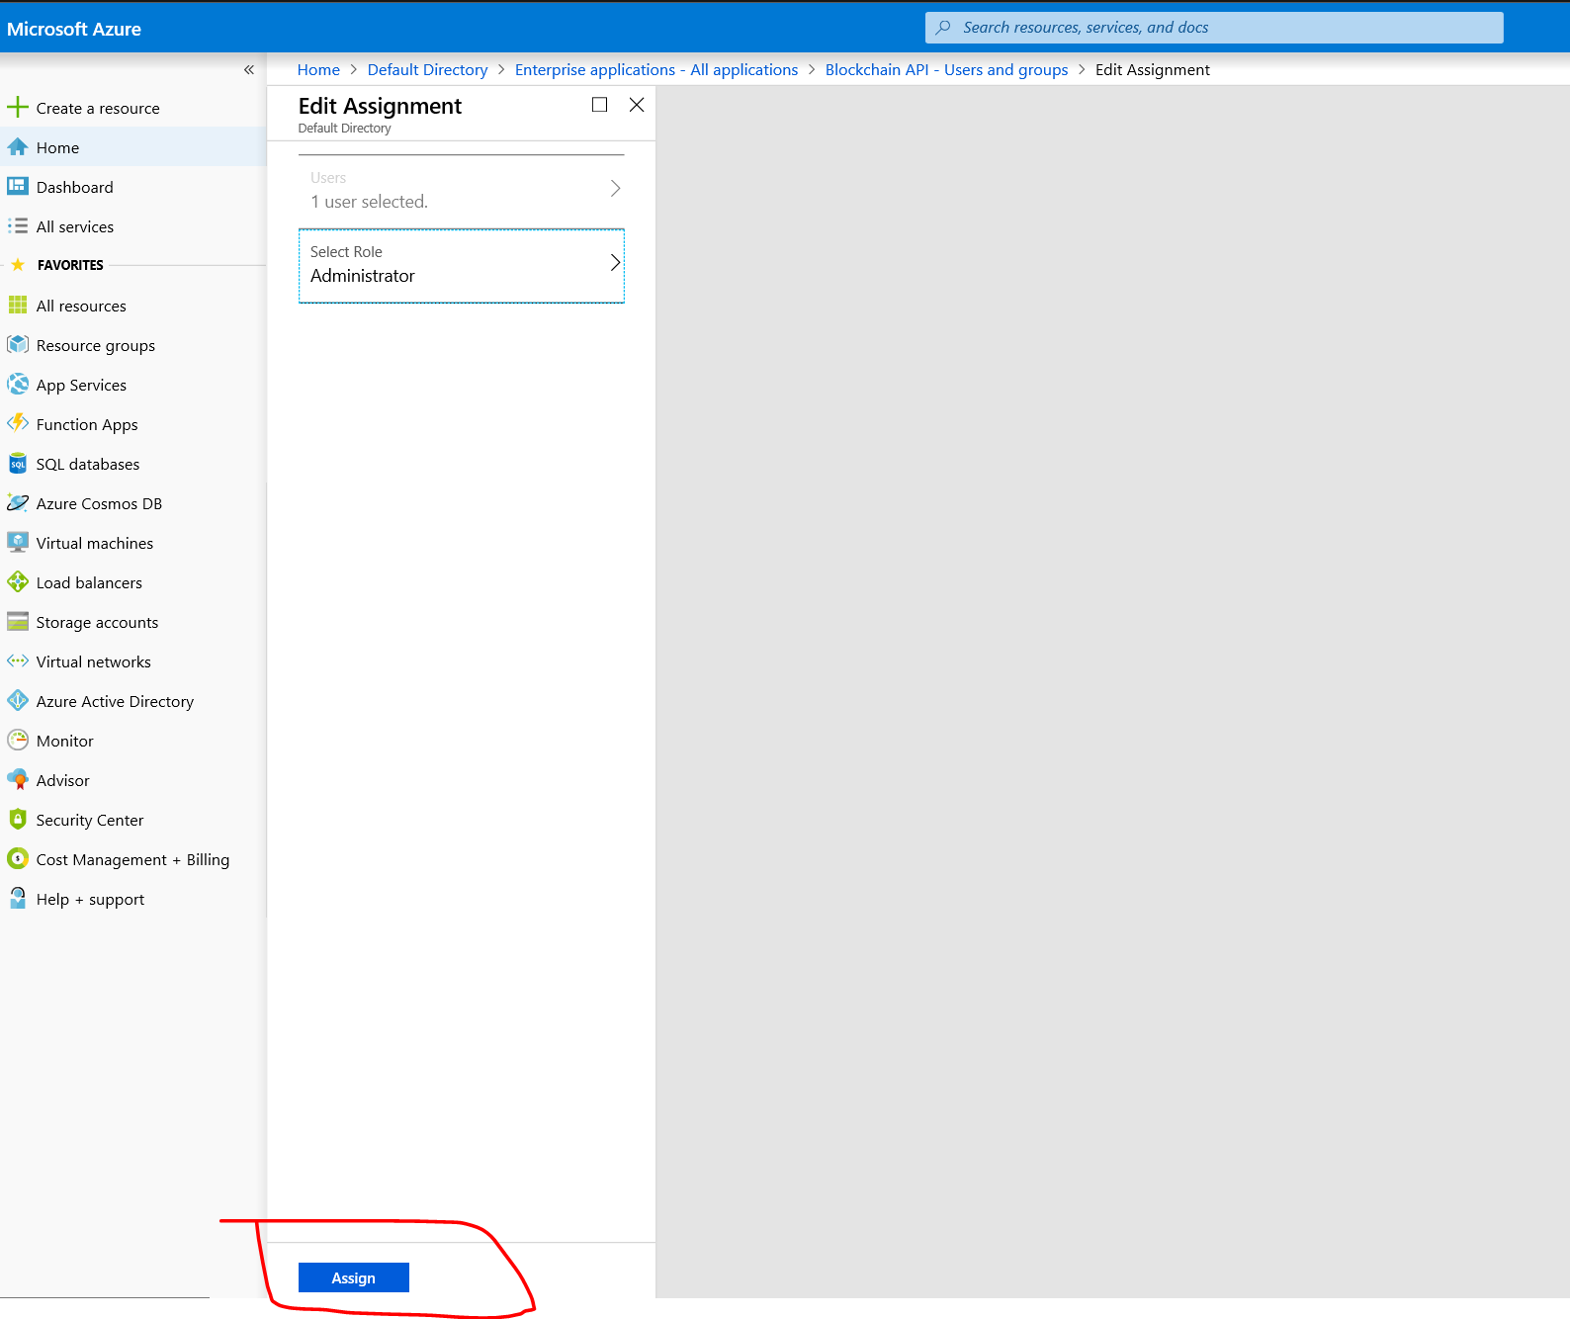

You have successfully applied the permission. Now go back to the Blockchain URL

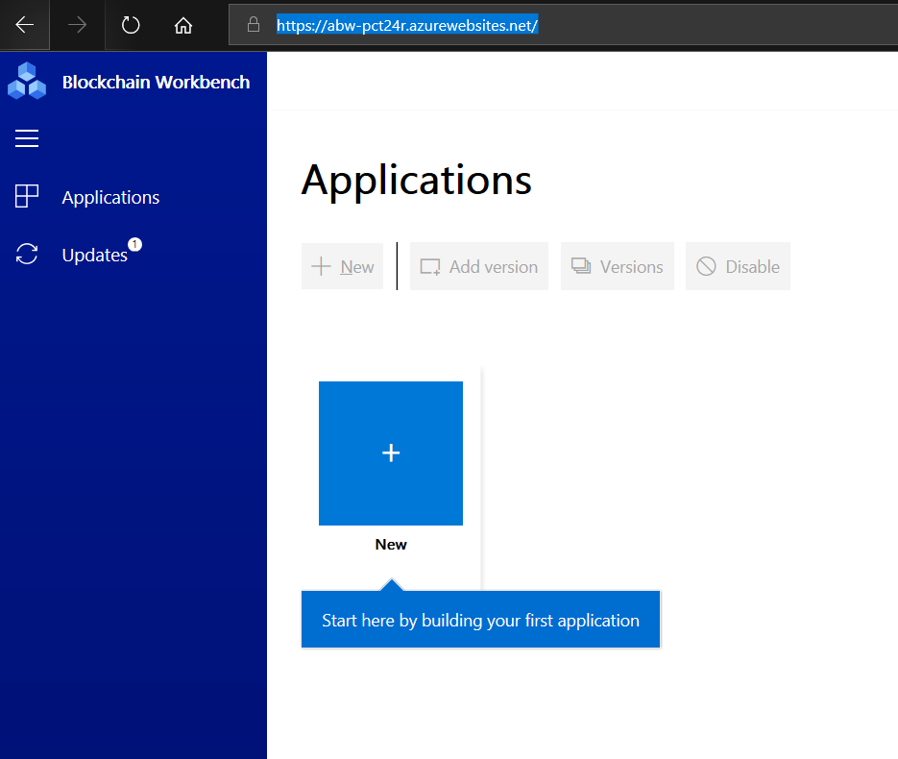

Now Refresh the Page

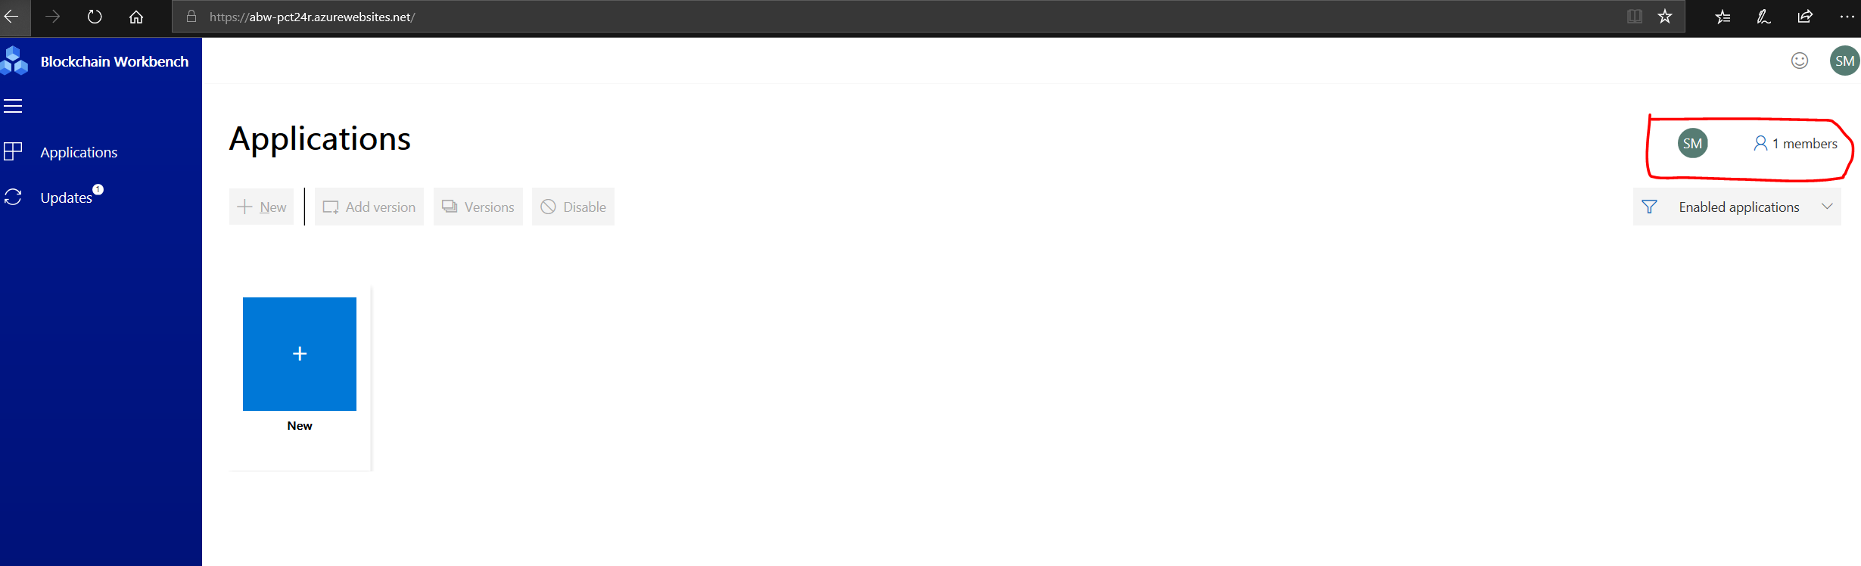

Now your login will be the Administrator. You have successfully configured the Blockchain Application URL. Now you can start uploading Block chain apps into the URL.

# Adding Sample Applications

Follow the link here

<https://github.com/msisgreat/demo>

Download

**SAMPLE 1**

HelloBlockchain.json

HelloBlockchain.sol

**SAMPLE 2**

AssetTransfer.json

AssetTransfer.sol

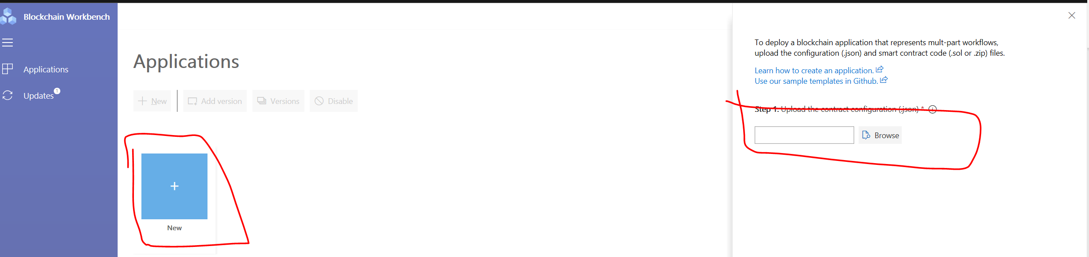

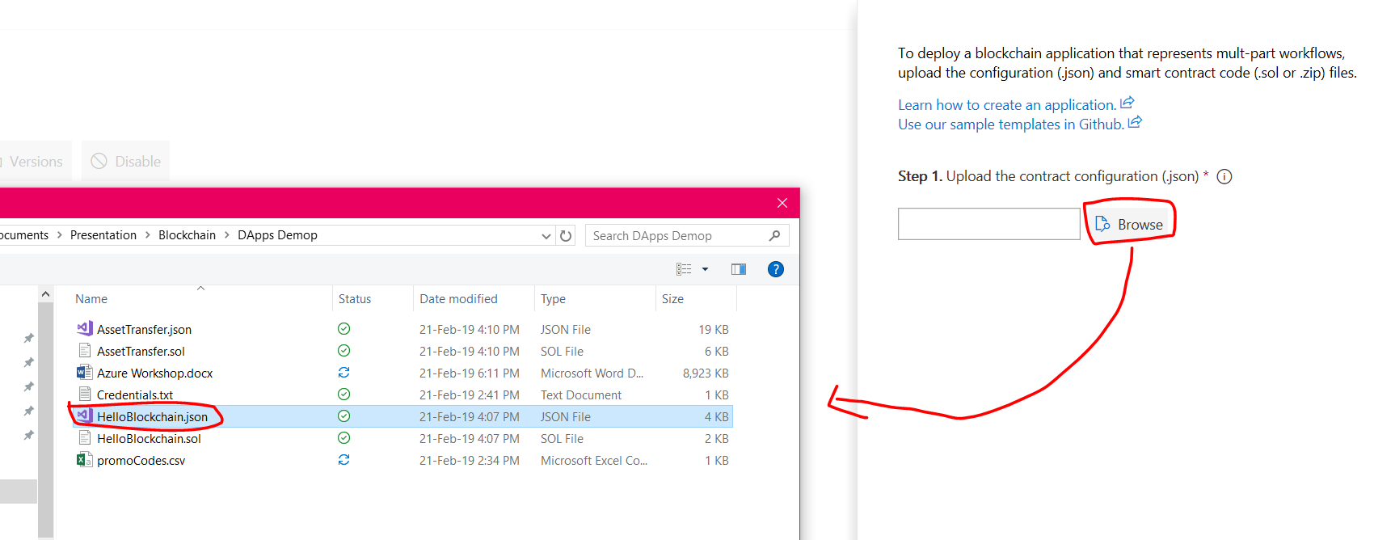

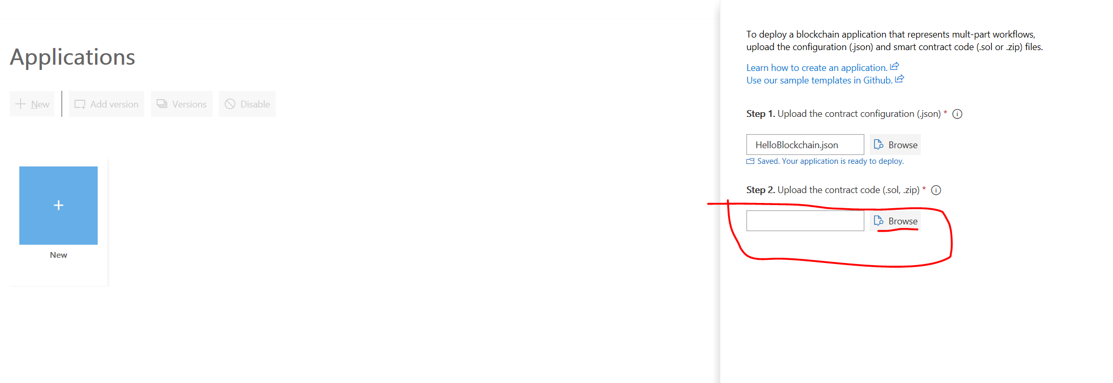

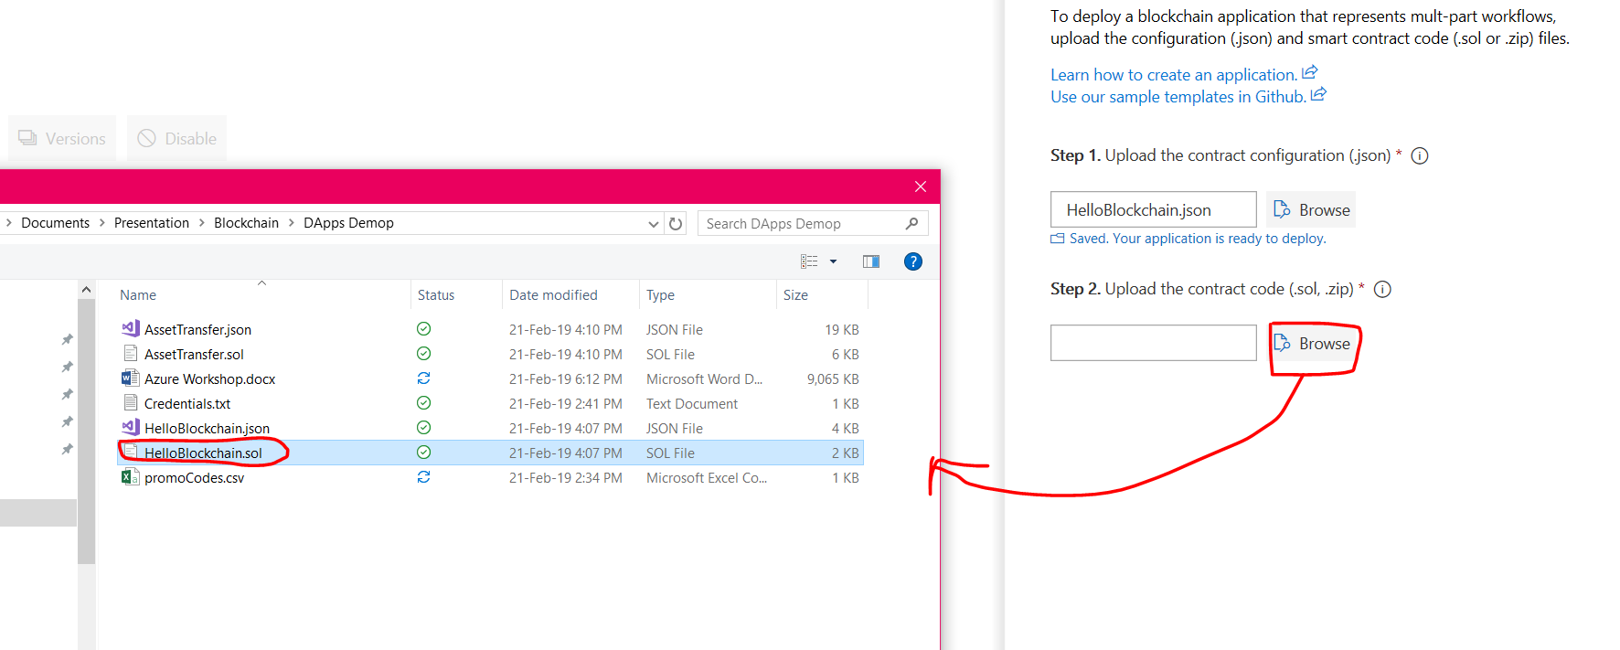

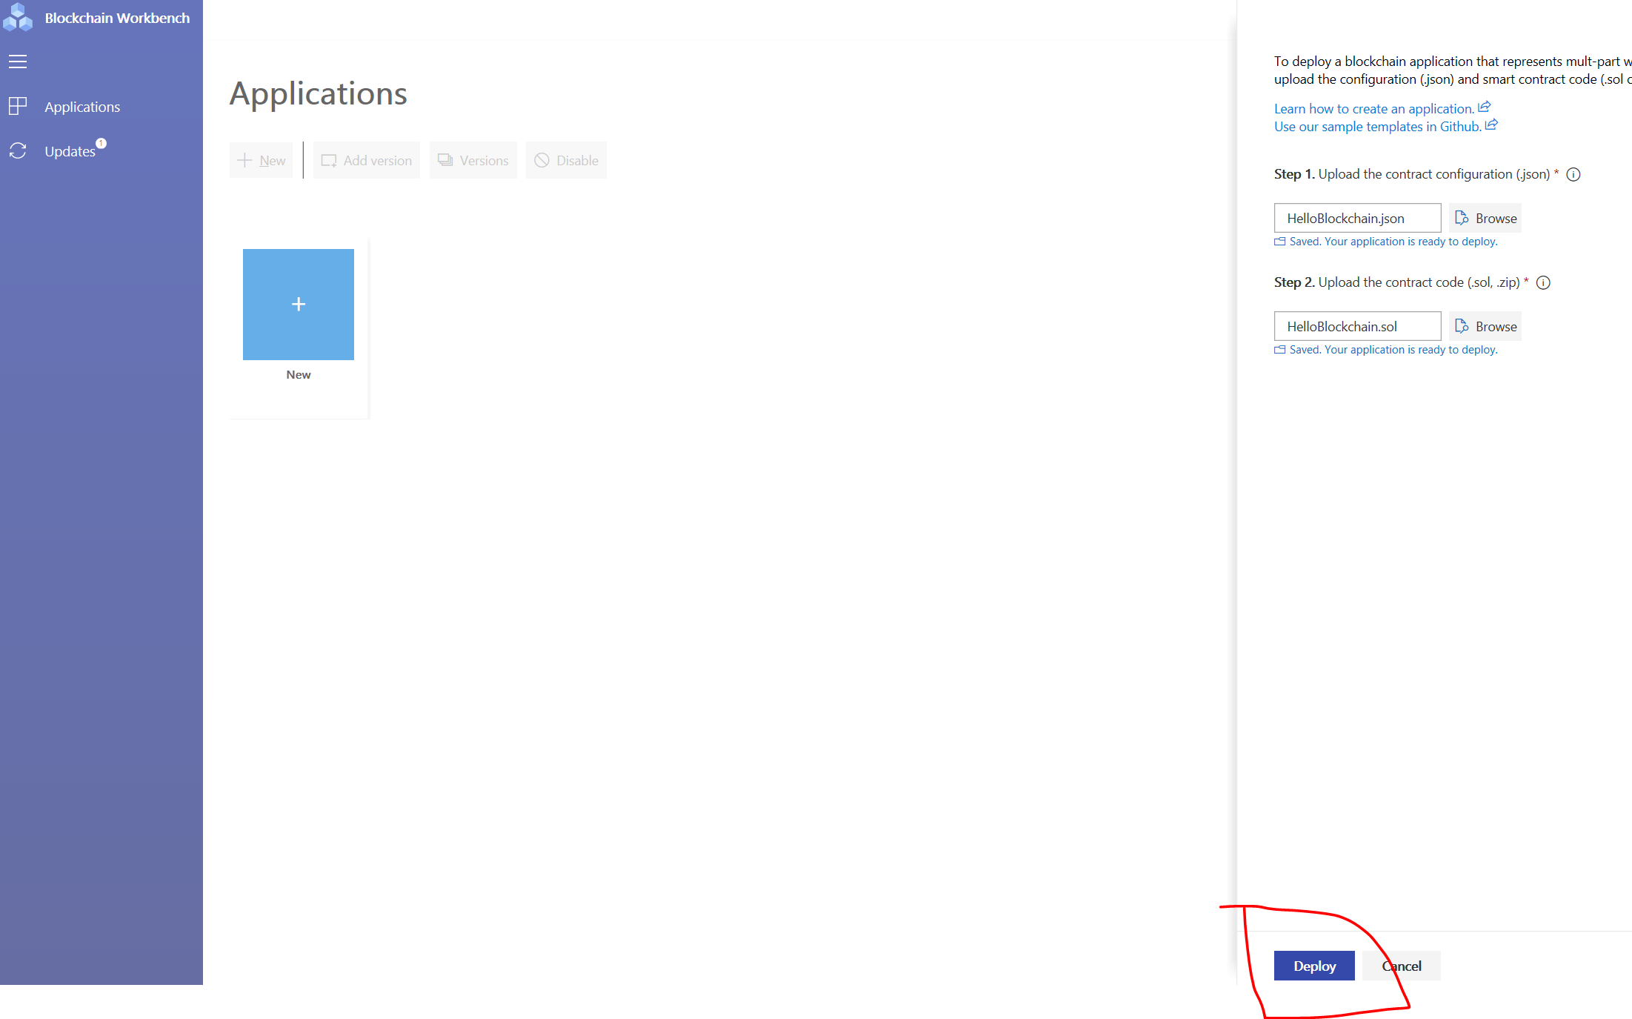

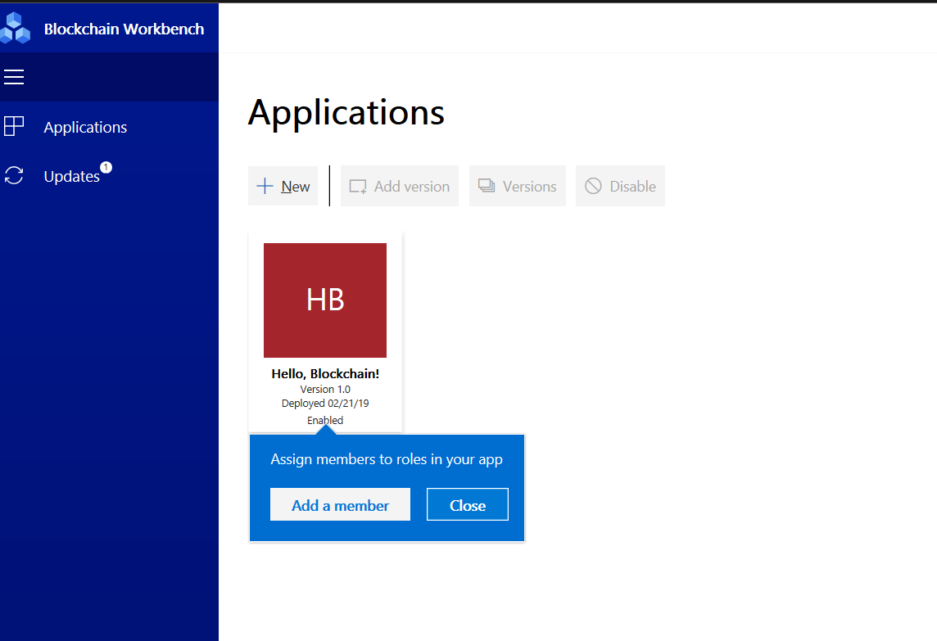

You have now successfully Added the Application from Sample.